PROJECT REPORT
On
ExamAI — AI-Powered Exam Preparation over Teacher-Approved Material
Submitted by
PATEL DHAIRYA (IU2341230041)
KHATRI KESHAV (IU2341230068)
PATEL SWET (IU2341230111)
In fulfillment for the requirements of Software Group Project as a part of BACHELOR OF TECHNOLOGY in COMPUTER SCIENCE AND ENGINEERING
INSTITUTE OF TECHNOLOGY AND ENGINEERING, INDUS UNIVERSITY CAMPUS, RANCHARDA, VIA-THALTEJ, AHMEDABAD-382115, GUJARAT, INDIA. WEB: www.indusuni.ac.in
NOV 2026

PROJECT REPORT ON ExamAI
PREPARED BY: Patel Dhairya (IU2341230041), Khatri Keshav (IU2341230068), Patel Swet (IU2341230111). UNDER GUIDANCE OF (Internal Guide): Ms. Shreya Bhatt, Assistant Professor, Department of Computer Science and Engineering, IITE, Indus University, Ahmedabad. SUBMITTED TO: Institute of Technology and Engineering, Indus University. NOV 2026.

CANDIDATE'S DECLARATION
I declare that the final semester report entitled “ExamAI” is my own work conducted under the supervision of the guide Ms. Shreya Bhatt. I further declare that to the best of my knowledge, the report does not contain part of the work submitted for the award of B.Tech Degree either in this university or any other university without proper citation. Candidate's Signature — PATEL DHAIRYA (IU2341230041). Guide: Ms. Shreya Bhatt, Assistant Professor, CSE, Indus Institute of Technology and Engineering, Indus University, Ahmedabad.

CANDIDATE'S DECLARATION
I declare that the final semester report entitled “ExamAI” is my own work conducted under the supervision of the guide Ms. Shreya Bhatt. I further declare that to the best of my knowledge, the report does not contain part of the work submitted for the award of B.Tech Degree either in this university or any other university without proper citation. Candidate's Signature — KHATRI KESHAV (IU2341230068). Guide: Ms. Shreya Bhatt, Assistant Professor, CSE, Indus Institute of Technology and Engineering, Indus University, Ahmedabad.

CANDIDATE'S DECLARATION
I declare that the final semester report entitled “ExamAI” is my own work conducted under the supervision of the guide Ms. Shreya Bhatt. I further declare that to the best of my knowledge, the report does not contain part of the work submitted for the award of B.Tech Degree either in this university or any other university without proper citation. Candidate's Signature — PATEL SWET (IU2341230111). Guide: Ms. Shreya Bhatt, Assistant Professor, CSE, Indus Institute of Technology and Engineering, Indus University, Ahmedabad.

COLLEGE CERTIFICATE
This is to certify that the Software Group Project work entitled ‘ExamAI — AI-Powered Exam Preparation over Teacher-Approved Material’ has been carried out by Patel Dhairya, Khatri Keshav and Patel Swet under the guidance of Ms. Shreya Bhatt in partial fulfillment of the requirements for the Bachelor of Technology in Computer Science and Engineering (7th Semester) of Indus University, Ahmedabad during the academic year 2026. Signatories: Ms. Shreya Bhatt (Guide) | Dr. Kaushal Jani (Head of Department) | Prof. Zalak Vyas (Head of Department). Date: __/10/2026.

ACKNOWLEDGEMENT
We thank our internal guide, Ms. Shreya Bhatt, Assistant Professor, Department of Computer Science and Engineering, for her constant guidance — from finalizing the project scope, through the system design and RAG architecture reviews, to the final report. We thank Dr. Kaushal Jani and Prof. Zalak Vyas, Heads of the Department of Computer Science and Engineering, and the faculty of Indus Institute of Technology and Engineering for their encouragement and for an environment that supports independent, practical project work. We also thank Mr. Jignesh Patel for his help in identifying and defining the project topic. Finally, we thank our families and friends for their patience and support during the many hours spent building, testing and documenting this project. — Patel Dhairya (IU2341230041), Khatri Keshav (IU2341230068), Patel Swet (IU2341230111), Computer Science & Engineering.

ABSTRACT
ExamAI is a full-stack, AI-powered exam-preparation platform designed to connect students with teacher- approved learning material. The platform combines retrieval-augmented generation (RAG) chat, teacher- authored shared quizzes, AI-assisted quiz generation, and student-owned flashcard decks in one web application. It provides separate workflows for students, teachers, and administrators while keeping authorization, material ownership, and academic comparability explicit in the system design. Students can select a subject, choose the approved materials that should scope a study session, ask questions, receive answers with teacher and filename attribution, attempt published quizzes, review weak topics, and generate flashcards. Teachers can upload PDF, PPTX, and DOCX materials, monitor ingestion status, author or generate quizzes, publish shared assessments, and review class-wide analytics. Administrators can manage teacher/student accounts, subjects, and teacher assignments / student enrollments through the admin console. The backend uses FastAPI, SQLAlchemy, Alembic, Supabase Postgres and Auth, Gemini, Qdrant Cloud, and local sentence-transformer embeddings. The frontend uses React, Vite, React Router, Zustand, Tailwind CSS, and reusable interface primitives. The project demonstrates secure role-based access, metadata- filtered retrieval, concurrent ingestion protection, structured-output retry handling, server-side quiz grading, and measured frontend performance. The current implementation contains 103 offline backend tests and 84 frontend tests. The report presents the motivation, objectives, literature and technology overview, project management approach, requirements, system analysis, detail description, testing, system design, results, limitations, future enhancements, and conclusion of the ExamAI project.

COMPANY PROFILE
There is no external company for this Software Group Project. ExamAI is an in-house academic project carried out at the Institute of Technology and Engineering, Indus University, under the internal guidance of Ms. Shreya Bhatt (Assistant Professor, Department of Computer Science and Engineering). The reference production layout is Render.com (backend API) + static frontend hosting + managed Supabase (Postgres, Auth, Storage) and Qdrant Cloud services.

TABLE OF CONTENT
Title
ABSTRACT i
COMPANY PROFILE ii
LIST OF FIGURES vi
LIST OF TABLES viii
ABBREVIATIONS ix
CHAPTER 1 INTRODUCTION 2
1.1 Project Summary 2
1.2 Project Purpose 2
1.3 Project Scope 3
1.4 Objectives 3
1.4.1 Main Objectives 4
1.4.2 Secondary Objectives 4
1.5 Technology and Literature Overview 4
1.5.1 Retrieval-Augmented Generation 4
1.5.2 Vector Search and Embeddings 4
1.5.3 Programming Languages 5
1.5.4 Libraries and Tools 5
1.5.5 Literature Overview 5
1.6 Synopsis 5
CHAPTER 2 LITERATURE SURVEY 8
2.1 Introduction of Survey 8
2.2 Why Survey? 8
2.3 Existing System vs Proposed System 8
CHAPTER 3 PROJECT MANAGEMENT 12
3.1 Project Planning Objectives 12
3.2 Software Scope 12
3.3 Resource 12
3.3.1 Human Resource 12
3.3.2 Reusable Software Resources 13
3.3.3 Environment Resource 13
3.4 Project Development Approach 13
3.5 Project Scheduling 13
3.5.1 Basic Principle 13
3.5.2 Compartmentalization 13
3.5.3 Work Breakdown Structure 14
3.5.4 Project Organization 14
3.5.5 Timeline Chart 15
3.5.5.1 Time Allocation 15
3.5.5.2 Task Sets 15
3.6 Risk Management 15
3.6.1 Risk Identification 16
3.6.2 Risk Identification Artifacts 16
3.6.3 Risk Projection 16
CHAPTER 4 SYSTEM REQUIREMENTS 19
4.1 User Characteristics 19
4.2 Functional Requirement 19
4.3 Activity and Proposed System 20
4.4 Non Functional Requirement 20
4.5 Hardware and Software Requirement 21
CHAPTER 5 SYSTEM ANALYSIS 23
5.1 Study of Current System 23
5.2 Problems in Current System 23
5.3 Requirement of New System 23
5.4 Process Model 23
5.5 Feasibility Study 24
5.5.1 Technical Feasibility 24
5.5.2 Operational Feasibility 24
5.5.3 Economical Feasibility 24
5.5.4 Schedule Feasibility 24
5.6 Features of New System 24
CHAPTER 6 DETAIL DESCRIPTION 27
6.1 Student Module 27
6.2 Teacher Module 27
6.3 Administrator Module 27
CHAPTER 7 TESTING 29
7.1 Black-Box Testing 29
7.2 White-Box Testing 29
7.3 Test Cases 30
CHAPTER 8 SYSTEM DESIGN 33
8.1 System Architecture 33
8.2 Class Diagram 34
8.3 Use-Case Diagram 34
8.4 Sequence Diagram 35
8.5 Activity Diagram 36
8.6 Data Flow Diagram (DFD) 37
8.6.1 Level 0 DFD 37
8.6.2 Level 1 DFD 38
8.7 Data Model 38
CHAPTER 9 RESULT AND DISCUSSION 41
9.1 Login and Role-Based Access 41
9.2 Student Dashboard and Subject View 41
9.3 RAG Chat with Material Scope and Citations 43
9.4 Quiz Taking and Feedback 44
9.5 Flashcard Generation and Study 46
9.6 Teacher Material Management 48
9.7 Teacher Quiz Authoring and Publishing 49
9.8 Teacher Analytics and Student Progress 50
9.9 Admin Console and Membership Management 52
9.10 Security and Reliability Results 55
9.11 Overall System Performance 55
CHAPTER 10 LIMITATION AND FUTURE ENHANCEMENT 57
10.1 Limitation 57
10.2 Future Enhancement 57
CHAPTER 11 CONCLUSION 59
11.1 Conclusion 59
CHAPTER 12 APPENDICES 61
12.1 Business Model 61
12.2 Product Deployment Detail 61
12.3 API and Web Service Details 61
BIBLIOGRAPHY 63

LIST OF FIGURES
Figure No | Title | Page No.
Figure 8.1 | System architecture | 33
Figure 8.2 | Class diagram | 34
Figure 8.3 | Use-case diagram | 35
Figure 8.4 | RAG chat sequence | 36
Figure 8.5 | Material ingestion activity | 37
Figure 8.6.1 | Level 0 DFD | 38
Figure 8.6.2 | Level 1 DFD | 38
Figure 9.1 | Sign-in form — email and password only, no signup or role selector | 41
Figure 9.2 | Student dashboard — study hero, quick stats, and enrolled subjects with teachers and progress | 42
Figure 9.3 | Subject resources — approved materials grouped by teacher with filter; only ready items are visible to students | 43
Figure 9.4 | RAG chat — per-session material scope, numbered citations with teacher/file tooltip, and grounded refusal of an off-corpus question | 44
Figure 9.5 | Published quiz list with scores | 45
Figure 9.6 | Quiz taking — one question at a time under a visible countdown with Previous/Next navigation | 45
Figure 9.7 | Result card — grade, score, and per-topic areas to review | 46
Figure 9.8 | Question review — per-question correct/wrong marking against the correct choice | 46
Figure 9.9 | Flashcard deck list with mastery progress | 47
Figure 9.10 | Flip-study view — question front with answer reveal and mastery controls | 48
Figure 9.11 | Teacher materials — upload dropzone, subject tabs, owner column separating own vs co-teacher files, Ready status badges | 49
Figure 9.12 | Teacher quiz list — draft/published badges, manual/AI source tags, publish flow | 50
Figure 9.13 | Per-quiz analytics — class stats, accuracy heatmap, grade distribution, weak topics | 51
Figure 9.14 | Student progress roster — averages, completion, at-risk flags with drill-down | 51
Figure 9.15 | Teacher dashboard overview — activity stats, recent completions, grade distribution, AI insights | 52
Figure 9.16 | Admin users — full account list with search, role filter, and per-row subject drill-down | 53
Figure 9.17 | Admin user drill-down — expanded teacher row with assigned subjects | 53
Figure 9.18 | Admin subjects — full subject list with add action | 54
Figure 9.19 | Admin subject drill-down — expanded subject with teacher and student rosters | 54
Figure 9.20 | Admin membership — assign or remove teacher/student by subject, kind, and user | 55

LIST OF TABLES
Table No | Title | Page No.
Table 2.3 | Existing systems vs ExamAI | 9
Table 3.1 | Work breakdown structure | 14
Table 3.2 | Time allocation | 15
Table 3.3 | Task sets | 15
Table 3.4 | Risk management | 16
Table 4.2 | Functional requirements | 20
Table 4.4 | Non-functional requirements | 21
Table 4.5 | Software stack (as used) | 21
Table 7.1 | Representative test cases | 31
Table 8.1 | System architecture layers and responsibilities | 34
Table 12.1 | Product deployment layout | 61
Table 12.2 | API and web service summary | 62

ABBREVIATIONS
Abbreviation | Full Form
AI | Artificial Intelligence
API | Application Programming Interface
CORS | Cross-Origin Resource Sharing
CRUD | Create, Read, Update, Delete
CSS | Cascading Style Sheets
DFD | Data Flow Diagram
DOCX | Word Open XML Document
HTTP | HyperText Transfer Protocol
JSON | JavaScript Object Notation
JSX | JavaScript XML
JWT | JSON Web Token
LLM | Large Language Model
LMS | Learning Management System
MOOC | Massive Open Online Course
ORM | Object Relational Mapping
PDF | Portable Document Format
PPTX | PowerPoint Open XML Presentation
RAG | Retrieval-Augmented Generation
RBAC | Role-Based Access Control
REST | Representational State Transfer
SDK | Software Development Kit
SQL | Structured Query Language
UI | User Interface
UX | User Experience
UUID | Universally Unique Identifier

CHAPTER 1
INTRODUCTION

▪ PROJECT SUMMARY
▪ PROJECT PURPOSE
▪ PROJECT SCOPE
▪ OBJECTIVES
▪ TECHNOLOGY AND LITERATURE OVERVIEW
▪ SYNOPSIS

CHAPTER 1 INTRODUCTION

1.1 Project Summary
ExamAI is a web application built to make exam preparation more trustworthy and less fragmented for students, while giving teachers control over the material that AI-assisted study is grounded in. Today a student preparing for an examination typically searches through several files, asks a general-purpose chatbot that cannot say where its answer came from, practices from quiz links that differ from student to student, and revises from self-made notes. A teacher, meanwhile, distributes material in one place, collects quiz responses in another, and interprets class performance largely by hand.
ExamAI brings these activities into a single role-aware platform. A student selects an enrolled subject, chooses which teacher-approved materials should scope a study session, asks questions, and receives answers with numbered citations that identify the teacher, the file, and the page or slide each claim comes from. The same student attempts the same published quiz as every classmate in the subject, receives per-question feedback with weak topics, and generates personal flashcard decks from selected material for revision. A teacher uploads PDF, PPTX and DOCX materials, monitors their processing status, authors quizzes manually or with AI assistance, publishes them for the class, and reviews performance through per-quiz analytics and cross-quiz student progress views.
The application is built using React for the frontend, FastAPI (Python) for the backend, PostgreSQL for relational data, Qdrant for vector retrieval, and Gemini for structured generation. Access control follows subject membership on both sides: teachers act through subject membership, students through subject enrollment. A third global role, administrator, provisions users, subjects, and memberships through the admin console (/api/admin/*, /admin/*) via require_admin and is never subject-scoped.

1.2 Project Purpose
The purpose of ExamAI is to give students one reliable place to prepare for examinations from material their teachers actually approve — and to make every AI-generated answer traceable back to that material. An answer that cannot say which teacher's file and which page it came from leaves a student with no one to ask when in doubt. ExamAI treats attribution as a core requirement, not a cosmetic addition: each citation carries the teacher's name, the filename, and the source page or slide, so a confused student knows exactly who to contact. (Contacting the teacher remains out of scope; the system only surfaces who and what.)
For teachers, the purpose is complementary: a practical way to distribute approved material, create comparable assessments in which every student answers the same questions, and inspect class-wide progress instead of reconciling scattered quiz tools. Building it as one system, rather than four disconnected tools, keeps study activity, assessment, and analytics connected by the same data and authorization rules.

1.3 Project Scope
The system is capable of:
- Secure email/password login for provisioned users, with the role (student, teacher, or admin) derived from the backend profile.
- Subject dashboards: enrolled subjects for students, teaching subjects for teachers, with multi-teacher subjects supported. Administrators use a separate console (/admin/*: Users, Subjects, Membership) rather than a subject dashboard.
- Teacher-owned material uploads (PDF, PPTX, DOCX, 25 MB limit) with processing / ready / failed status, retry, and deletion.
- Subject-scoped RAG chat over a per-session material selection, returning answers with numbered teacher/file/page citations.
- Manual and AI-assisted quiz authoring converging on the same question shape, with a draft → review → publish flow.
- Shared published quizzes: all students in a subject take the same quiz; server-side grading with per-question feedback and weak-topic detection.
- Student-owned flashcard deck generation from selected materials, with mastery tracking (new / learning / mastered).
- Teacher analytics: per-quiz views (accuracy heatmap, grade distribution, weak topics) and cross-quiz student progress (averages, completion, at-risk flags, drill-down).
- Administration console: an admin role (seeded as admin@examai.com) manages teacher/student accounts, subjects, and teacher assignments / student enrollments through /api/admin/* and the /admin/* Users, Subjects, and Membership pages. Admins cannot create other admins and never bypass subject membership checks — they only manage them.
The current version has a few known limits:
- It is a web application only — there is no mobile app yet.
- Users are provisioned by an explicit seed operation (which creates the admin@examai.com administrator) plus runtime admin user management; there is no public signup, password reset, or OAuth.
- There is no in-app teacher–student messaging or broadcast.
- Student-generated graded quizzes are deferred as explicit v2 scope, to protect the fairness of shared assessment.
- Retrieval is dense-vector only; hybrid dense-plus-sparse search is a flagged future enhancement, not part of this delivery.
- The live behaviour of generation features depends on the configured Gemini model, quota and billing, which must be verified per deployment (the configured default is gemini-2.5-flash).

1.4 Objectives

1.4.1 Main Objectives
- To build a single role-aware platform (student, teacher, admin) for AI-assisted exam preparation.
- To ground every study answer in teacher-approved material and attribute each claim to its teacher, file, and page or slide.
- To keep assessment fair by publishing one shared quiz per topic for all students in a subject.
- To return feedback beyond a total score: per-question results and weak-topic detection.
- To let students generate personal revision decks from their own selected materials.
- To give teachers class-wide comparability through per-quiz analytics and cross-quiz progress views.

1.4.2 Secondary Objectives
- To enforce subject membership and role authorization (including global require_admin for administration) in service-layer logic, not only in route declarations.
- To preserve source metadata end to end — parsing, chunking, embedding, retrieval, citation — so attribution never depends on a per-request database lookup.
- To handle structured model-output failures through schema-driven, error-aware retries.
- To keep the ingestion pipeline safe under concurrent upload, retry, and delete operations.
- To keep the codebase organized (thin routes, logic in services, schemas separate from models) so new features do not require rewriting old ones.

1.5 Technology and Literature Overview

1.5.1 Retrieval-Augmented Generation
Retrieval-augmented generation is an approach that combines information retrieval with language generation. Instead of asking a model to answer from its general training alone, the system first retrieves relevant passages from a controlled collection and supplies them as context, so the answer is grounded in identifiable sources. ExamAI uses this approach for subject chat and for AI-assisted quiz generation: retrieval is constrained by subject enrollment and the student's selected materials before the vector database is ever queried.

1.5.2 Vector Search and Embeddings
An embedding represents text as a numerical vector, so that semantically related passages can be compared by distance. ExamAI embeds material chunks locally with the all-MiniLM-L6-v2 sentence model and stores them in a single Qdrant collection shared across all subjects and materials. Each stored point carries payload metadata — subject, material, teacher, filename, teacher name, and a stable source locator (page, slide, or paragraph number) — which makes metadata-filtered retrieval and citation attribution possible without per-chunk database round-trips.

1.5.3 Programming Languages
Programming languages provide the instructions a computer executes to build software systems. ExamAI's backend and ingestion pipeline are written in Python, and its frontend is written in JavaScript (as React/JSX). Python was chosen for the backend because the AI ecosystem — embedding libraries, document parsers, and model clients — is strongest there; JavaScript/React was chosen for the frontend because the interface is a dynamic, stateful study workspace.

1.5.4 Libraries and Tools
The project uses several important libraries:
- React.js — used for building the interactive study interface (dashboards, chat, quiz taking, flashcards, analytics).
- Vite — provides fast builds and the development server for the frontend.
- FastAPI — the Python web framework serving the HTTP API, with automatic request validation and interactive API documentation.
- SQLAlchemy + Alembic — database access with defined schema, plus versioned migrations.
- Pydantic — validates API shapes and doubles as the structured-output contract for model generation.
- Supabase — provides authentication, PostgreSQL hosting, and private file storage.
- Qdrant client — metadata-filtered vector search over embedded material chunks.
- Zustand, React Router, Tailwind CSS — client state, navigation, and styling.

1.5.5 Literature Overview
Digital learning platforms have been studied and built extensively: learning-management systems organize content and grades, MOOC platforms deliver courses at scale, flashcard tools support spaced revision, and general-purpose chatbots answer arbitrary questions fluently. What the survey in Chapter 2 shows is that none of the widely used options combine the four properties an examination setting needs — teacher-approved sources, answers attributed to a teacher and page, one shared assessment for the whole class, and class-wide analytics — in a single system. ExamAI is built specifically to close that gap, as detailed in Chapter 2.

1.6 Synopsis
ExamAI is a web-based exam-preparation platform in which students study from teacher-approved materials through attributable RAG chat, take the same teacher-published quizzes as their classmates, revise with self-generated flashcards, teachers monitor class performance through analytics, and administrators provision users, subjects, and memberships through the admin console. It is built with React, FastAPI, PostgreSQL, Qdrant, and Gemini, with authorization enforced at the service layer and source metadata preserved from ingestion to citation. The following chapters present the literature survey, project management, requirements, analysis, detail description, testing, design, results, limitations, and conclusion of the project.

CHAPTER 2
LITERATURE SURVEY

▪ INTRODUCTION OF SURVEY
▪ WHY SURVEY?
▪ EXISTING SYSTEM VS PROPOSED SYSTEM

CHAPTER 2 LITERATURE SURVEY

2.1 Introduction of Survey
Before building ExamAI, widely used learning platforms and study tools were studied to understand what they already do well and where they fall short for examination preparation. The review focused on five popular, representative options that students and teachers actually use: Moodle (the most widely deployed open-source learning-management system), Google Classroom (the most widely used lightweight classroom platform), Quizlet (the most popular flashcard-based revision tool), general-purpose LLM chatbots such as ChatGPT (what students most commonly ask study questions today), and NotebookLM (Google's retrieval-grounded study assistant over user-supplied sources — the closest existing product to our approach).
The comparison was deliberately operational rather than theoretical: it asks what each system does about content ownership, answer traceability, assessment comparability, feedback, analytics, and access control — the six properties Section 1.5.5 identifies as necessary in an examination setting.

2.2 Why Survey?
A survey of existing platforms is useful because it shows what students and teachers can already do elsewhere, so a new project does not simply repeat what already exists. It also exposes real gaps that a new system can be built specifically to close, instead of guessing what users might need. For ExamAI, the survey served three concrete purposes. First, it confirmed that content management (Moodle, Classroom) and revision tools (Quizlet) exist but are disconnected from AI-grounded question answering. Second, it confirmed that students already use generic chatbots for study help — but those answers carry no source attribution, which is precisely the trust problem ExamAI addresses. Third, it positioned the closest alternative, NotebookLM, and showed where a classroom system must go further: teacher ownership, shared assessment, and class analytics, none of which a personal study assistant provides.

2.3 Existing System vs Proposed System
Sr. No. | Aspect | Existing Systems | ExamAI (Proposed)
1 | Source control | Moodle / Classroom store teacher files, but AI answers (ChatGPT) are disconnected from them; NotebookLM grounds answers only in the student's own uploads | Teacher-owned, subject-scoped, status-checked materials are the only retrieval corpus
2 | Answer traceability | ChatGPT answers carry no source; Classroom/Moodle have no QA at all; NotebookLM cites the student's documents, not a teacher | Every answer carries numbered citations with teacher name, filename, and page/slide locator
3 | Assessment fairness | Quizlet/Forms-style quizzes are typically per-link and incomparable across a class | One published quiz per topic for all students in the subject, enabling class-wide comparison
4 | Feedback depth | Scores usually stop at a total; weak-topic analysis is absent | Server-side grading returns per-question feedback plus weak-topic detection per attempt
5 | Teacher insight | Scattered gradebooks (Classroom), or nothing (chatbots, Quizlet) | Dedicated per-quiz analytics (heatmap, grade distribution) plus cross-quiz student progress with at-risk flags
6 | Access control | Coarse roles; students can paste any content into a chatbot | Service-layer membership checks (enrollment for students, subject membership for teachers, global require_admin for administrators) plus per-request material validation; admin-provisioned accounts replace public signup

Table 2.3: Existing systems vs ExamAI.
Three gaps appeared consistently across all five options studied:
- Attribution gap. The tools students actually ask questions of (generic chatbots) cannot say which teacher's file and which page an answer came from. The tools that organize teacher files (Moodle, Classroom) cannot answer questions at all.
- Comparability gap. Revision and quiz tools are built around individual practice links. Nothing guarantees that every student in a class answers the same questions, so teachers cannot compare performance fairly.
- Oversight gap. No surveyed option connects study help, assessment, and class-wide analytics through one authorization model. Teachers either get a gradebook without study context, or study tools without any teacher visibility.
ExamAI is built directly around closing these three gaps: teacher-owned retrieval with teacher-attributed citations, shared published quizzes, and analytics fed by the same attempts — all guarded by subject membership, with administrator-provisioned accounts and memberships replacing public signup.

CHAPTER 3
PROJECT MANAGEMENT

▪ PROJECT PLANNING OBJECTIVES
▪ SOFTWARE SCOPE
▪ RESOURCE
▪ PROJECT DEVELOPMENT APPROACH
▪ PROJECT SCHEDULING
▪ RISK MANAGEMENT

CHAPTER 3 PROJECT MANAGEMENT

3.1 Project Planning Objectives
- Define clear goals — what the platform must do for students, for teachers, and for administrators — before writing any code.
- Gather requirements from the literature survey, fixing the teacher-owned / shared-assessment / attributable-answer boundaries early.
- Design the system — data model, service boundaries, and API contracts — before building features on top of them.
- Build in dependency order — authentication and data access first, then materials, then ingestion, then retrieval, then quizzes and flashcards, then analytics — so each layer can be checked before the next is built on it.
- Validate risky integrations early (vector retrieval, structured model output, concurrent ingestion) behind service boundaries.
- Test continuously — offline backend and frontend suites run throughout, not only at the end.
- Keep a stable, working build ahead of every review milestone, deferring explicit v2 scope rather than destabilizing the core.

3.2 Software Scope
ExamAI is an in-house academic Software Group Project — there is no external company or client. The software scope covers a role-aware web platform with three roles (student, teacher, admin): teacher-owned material ingestion (PDF, PPTX, DOCX), metadata-filtered RAG chat with teacher/file/page citations, shared published quizzes with server-side grading, personal flashcard decks, class-wide analytics, and an administration console (user/subject/membership management via /api/admin/* and /admin/*). Out of scope (explicit v2): student-generated graded quizzes, in-app messaging/broadcast, mobile clients, hybrid retrieval, and institutional identity integration.

3.3 Resource

3.3.1 Human Resource
- Internal Guide (Ms. Shreya Bhatt, Assistant Professor, CSE): scope approval, design and RAG-architecture feedback, milestone reviews, report evaluation.
- Patel Swet (IU2341230111) — core development: system architecture, backend services, AI/RAG pipeline, data model and API contracts.
- Khatri Keshav (IU2341230068) — frontend support: study and dashboard interface work.
- Patel Dhairya (IU2341230041) — backend support: route/handler assistance, validation, service-level support.
- End users: students, teachers, and administrators, whose needs define acceptance. (Detailed responsibility split: Section 3.5.4.)

3.3.2 Reusable Software Resources
Open-source and managed reusable components (versions as used): React 19, Vite 8, React Router 7, Zustand 5, Tailwind CSS 4; Python 3.14, FastAPI, Uvicorn, SQLAlchemy 2 + Alembic, Pydantic 2; sentence-transformers (all-MiniLM-L6-v2), qdrant-client ≥ 1.16, Gemini API (gemini-2.5-flash configured default — verify per deployment); Supabase Postgres + Auth + private Storage; Qdrant Cloud; pytest (103 backend tests), Vitest + Testing Library (84 frontend tests).

3.3.3 Environment Resource
Local development runs from backend/ with the canonical backend/venv/ (Python 3.14.6) plus Node 20.19+/22.12+ for the frontend; migrations via Alembic, demo data via the seed command, Qdrant collection via the provision command. Reference production layout: Render.com (API) + static frontend hosting + managed Supabase and Qdrant services.

3.4 Project Development Approach
ExamAI was built with an incremental development model: requirements were converted into data and service contracts, then each phase delivered a vertical slice across backend and frontend, tested offline where possible, and reviewed before the next slice began. External-service risks (model availability, vector-database behaviour, embedding cost) were isolated behind utility and service boundaries, so core logic never depends directly on a vendor response shape. Cleanup and hardening passes followed once features stabilized.

3.5 Project Scheduling

3.5.1 Basic Principle
The project was built in layers, one on top of the other: authentication and the relational data model first, then subject and material management, then the ingestion pipeline, then RAG chat, then quizzes and flashcards, and finally analytics and hardening. Each layer was verified on its own — for example, retrieval filtering was tested against seeded data before any generation feature consumed it — so problems were caught early, one layer at a time.

3.5.2 Compartmentalization
The system was split into clear, separate modules so each part could be built and tested on its own: a data layer (users, subjects, memberships, materials, quizzes, attempts, decks), a backend service layer (ingestion, retrieval, generation, grading, analytics, administration), an API layer of thin route handlers (including /api/admin/*), and a frontend layer (pages including the /admin/* Users/Subjects/Membership console, stores, API client). The Pydantic schemas shared between the API and the model-output contracts act as the agreed interfaces between modules. Splitting the work this way meant a bug in one module rarely affected the others, and responsibilities could be divided among team members along module lines (Section 3.5.4).

3.5.3 Work Breakdown Structure
Phase | Primary work | Main outcome
0 — Foundations | Authentication, schema, migrations, project conventions | Seeded login with role derivation (student, teacher, admin); versioned data model
1 — Subject & material access | Roles, enrollment, teacher-owned material management | Membership-gated subject views; upload with status tracking
2 — Ingestion | PDF/PPTX/DOCX parsing, chunking, embeddings, Qdrant upserts | processing → ready / failed pipeline with retry and safe delete
3 — RAG chat | Filtered retrieval, citation mapping, structured generation | Attributable answers scoped to per-session material selection
4 — Quizzes | Manual + AI-assisted authoring, publish flow, server-side grading | Shared published quizzes with feedback and weak topics
5 — Flashcards | Student-owned deck generation, mastery tracking | Personal revision decks from selected materials
6 — Analytics & performance | Per-quiz and cross-quiz read models; frontend optimization | Teacher dashboards; route splitting, caching, prefetch behaviour
7 — Hardening | Auth hardening, concurrency guards, test suites, cleanup | 103 offline backend tests; 84 frontend tests; audit fixes
8 — Administration console | Admin API (/api/admin/*), /admin/* Users/Subjects/Membership pages, seed admin | admin@examai.com provisioning; require_admin gating; 19 backend + 16 frontend admin tests

Table 3.1: Work breakdown structure.

3.5.4 Project Organization
- Internal Guide (Ms. Shreya Bhatt, Assistant Professor, CSE): guides and reviews the project — scope approval, design and RAG-architecture feedback, milestone reviews, and report evaluation.
- Patel Swet (IU2341230111) — core development: system architecture, backend services and integration, AI/RAG pipeline (ingestion, retrieval, citations, generation, retries), data model and API contracts, and overall technical integration.
- Khatri Keshav (IU2341230068) — frontend support: study and dashboard interface work — pages, components, loading/empty/error states, and client-side presentation behaviour.
- Patel Dhairya (IU2341230041) — backend support: supporting backend functionality outside the core AI/RAG implementation — route/handler assistance, validation, and service-level support tasks.
- End users: students (study, quizzes, revision), teachers (materials, assessments, analytics), and administrators (user/subject/membership provisioning via the admin console), whose needs define acceptance.
This allocation reflects the work actually performed: the core AI/RAG architecture, retrieval pipeline, and system integration were built by Swet; Keshav and Dhairya hold contained, viva-explainable responsibilities in the frontend and supporting backend respectively.

3.5.5 Timeline Chart

3.5.5.1 Time Allocation
Development ran over fourteen weeks, from the last week of July 2026 to the last week of October 2026 (repository history: first commit 24 Jul 2026), ahead of the November 2026 submission.
Phase | Duration | Description
Requirement analysis | 2 weeks (24 Jul – 6 Aug) | Survey of existing platforms (Chapter 2), scope and role definition.
System design | 2 weeks (7 – 20 Aug) | Data model, service boundaries, API contracts, UI layout.
Development | 6 weeks (21 Aug – 1 Oct) | Foundations → materials → ingestion → RAG chat → quizzes → flashcards → analytics, in dependency order.
Testing | 2 weeks (2 – 15 Oct) | Offline backend suite, frontend suite, manual end-to-end passes, bug fixes.
Hardening & documentation | 2 weeks (16 – 29 Oct) | Auth/concurrency review, cleanup, report writing, demo preparation.

Table 3.2: Time allocation.

3.5.5.2 Task Sets
Task set | Tasks
Requirements | Literature survey (Chapter 2), role/scope definition, API and data-model contracts.
Design | Relational schema + migrations, service boundaries, ingestion/retrieval contracts, UI layout.
Build | Auth → subjects/materials → ingestion → RAG chat → quizzes → flashcards → analytics, in dependency order.
Verification | 103 offline backend tests, 84 frontend tests, manual end-to-end passes, concurrency and auth review.
Documentation | Report chapters, figures/screenshots, demo preparation, stable build ahead of review.

Table 3.3: Task sets.

3.6 Risk Management

3.6.1 Risk Identification
Risk | Description | Mitigation Strategy
LLM model/quota changes | Generation features depend on a live model name, quota and billing. | Verify the live model early per deployment; schema-first prompts with error-aware retries so failures are structured, not silent.
Incorrect retrieval scope | Answers could cite material from a subject the student is not enrolled in. | Validate every material ID in Postgres before querying Qdrant; filter by both subject and material IDs (defence in depth).
Concurrent ingestion | Simultaneous upload / retry / delete could revive deleted rows or corrupt status. | Per-material locks, row-level guards, and version-safe conditional status updates.
Unclear role boundaries | Students reaching teacher functions or other subjects' content; admin misuse. | Service-layer membership checks on every subject-scoped operation plus global require_admin on administration endpoints; 403 (not 404) for unenrolled access; admins cannot create other admins or delete themselves.
Slow external services | Embedding, vector DB, or model latency hurting responsiveness. | Blocking work off the event loop; bounded caching and request deduplication on the client.
Scope creep | Personal quizzes, messaging, mobile apps delaying the core. | Explicit in-scope / future-scope split from Section 1.3, enforced at planning.
Time constraints | Any phase overrunning into review milestones. | Stable-build-ahead-of-review rule; risky integrations isolated behind service boundaries.

Table 3.4: Risk management.

3.6.2 Risk Identification Artifacts
The risk register above is the primary artifact: each risk carries a description and a mitigation strategy that maps to a concrete mechanism (Postgres pre-validation + Qdrant subject/material filters, per-material locks with version-safe status updates, service-layer membership checks, schema-first prompts with error-aware retries, bounded client caching with request deduplication). Phase exit criteria (stable build ahead of each review) act as the schedule-risk artifact.

3.6.3 Risk Projection
High-impact risks are incorrect retrieval scope and concurrent ingestion (data-integrity class) — projected as low probability after the service-layer guards, but monitored through the offline suites and manual end-to-end passes. Medium-impact risks are LLM model/quota changes and slow external services (deployment-environment class) — contained by configuration and by keeping blocking work off the event loop. Scope creep and time constraints are controlled by the explicit in-scope/future-scope split (Section 1.3) and the stable-build-ahead-of-review rule.

CHAPTER 4
SYSTEM REQUIREMENTS

▪ USER CHARACTERISTICS
▪ FUNCTIONAL REQUIREMENT
▪ ACTIVITY AND PROPOSED SYSTEM
▪ NON FUNCTIONAL REQUIREMENT
▪ HARDWARE AND SOFTWARE REQUIREMENTS

CHAPTER 4 SYSTEM REQUIREMENTS

4.1 User Characteristics
ExamAI has three kinds of users. Students can view enrolled subjects, scope study sessions to approved materials, ask questions, attempt published quizzes, review feedback, and generate and study flashcards. Teachers can manage subject materials (upload, monitor, retry, delete), author and publish quizzes manually or with AI assistance, and inspect quiz analytics and student progress. Administrators manage teacher/student accounts, subjects, and teacher assignments / student enrollments through the admin console (/api/admin/*, /admin/* Users, Subjects, Membership pages); they use no subject workspace and never bypass subject membership checks. No special technical knowledge is needed — the interface is designed to be usable by anyone comfortable browsing a normal website, and no user is assumed to understand vector search or language-model operation.

4.2 Functional Requirement
ID | Requirement
FR-01 | The system shall authenticate a provisioned user with email and password and derive the role (student, teacher, or admin) from the backend profile.
FR-02 | The system shall allow teachers to upload PDF, PPTX and DOCX materials for a subject, within the configured size limit.
FR-03 | The system shall process uploaded material and expose processing, ready, and failed status with retry and delete.
FR-04 | The system shall allow enrolled students to select ready materials to scope a study session.
FR-05 | The system shall return RAG answers with numbered citations identifying teacher, file, and source location.
FR-06 | The system shall allow teachers to create manual or AI-assisted quiz drafts in a common question shape.
FR-07 | The system shall require teacher publication before a quiz becomes available to students.
FR-08 | The system shall grade attempts on the server and return per-question feedback with weak topics.
FR-09 | The system shall generate personal flashcard decks from student-selected material, with mastery tracking.
FR-10 | The system shall provide per-quiz analytics and cross-quiz student progress views to teachers.
FR-11 | The system shall allow administrators to manage teacher/student accounts, subjects, and teacher assignments / student enrollments via /api/admin/* and the /admin/* console, gated by require_admin.

Table 4.2: Functional requirements.

4.3 Activity and Proposed System
A typical student activity begins with login and subject selection. The student opens the material-scope panel, chooses which ready materials should ground the session, and asks a question; the system returns an answer whose numbered citations identify the teacher and file behind each claim. The student may then attempt a published quiz under its time limit, review per-question feedback and weak topics, and generate a flashcard deck from the same or another material selection for revision.
A typical teacher activity begins with subject access, continues through material upload and ingestion monitoring, then quiz authoring — written manually or drafted by the AI from ready material and edited — followed by publication and analytics review. AI-generated quizzes always remain drafts until a teacher reviews and publishes them, keeping the teacher, not the model, responsible for assessment content. Saving personal study state is the student's domain; publishing shared assessment is the teacher's; provisioning accounts, subjects, and memberships is the administrator's; the system never mixes the three.

4.4 Non Functional Requirement
Category | Requirement
Security | Role and subject-membership authorization enforced in services (including global require_admin for administration; admins cannot create other admins); access tokens kept in memory, refresh via HttpOnly cookie; CORS allow-list.
Reliability | Malformed model output, failed ingestion, retry/delete races, and concurrent operations handled without corrupting state.
Performance | Blocking parser/embedding work kept off the event loop; frontend uses route splitting, bounded caching, request deduplication, and stale-response protection.
Maintainability | Thin routes, schemas separate from ORM models, business logic in services; shared contracts via API envelopes.
Usability | Loading, empty, failure, and success states throughout; the active material scope always visible to the student.
Traceability | Every citation retains teacher, file, and source-location metadata from ingestion to answer.

Table 4.4: Non-functional requirements.

4.5 Hardware and Software Requirement
Hardware Requirement. As a web application, ExamAI needs no special hardware — any device that can run a modern browser can use it.
- Processor: any modern dual-core processor or above.
- RAM: 4 GB or more (8 GB recommended for local backend development with local embeddings).
- Internet connection: required to reach the API and its managed services.
- Input/Output: a screen with keyboard/mouse or touchscreen.
Software Requirement.
Layer | Technology / version (as used in this project)
Frontend | React 19, Vite 8, React Router 7, Zustand 5, Tailwind CSS 4
Backend | Python 3.14, FastAPI, Uvicorn, SQLAlchemy 2 + Alembic, Pydantic 2
AI / retrieval | sentence-transformers (all-MiniLM-L6-v2), qdrant-client ≥ 1.16, Gemini (gemini-2.5-flash configured default — verify per deployment)
Data & files | Supabase Postgres + Auth + private Storage
Tooling | Git & GitHub; FastAPI Swagger UI (/docs); pytest (103 backend tests); Vitest + Testing Library (84 frontend tests)

Table 4.5: Software stack (as used).
Server Hosting Requirement. The system is developed and verified as a local prototype and is deployment-ready: the FastAPI backend runs under Uvicorn, the frontend builds to static assets via Vite, and data, authentication, and file storage target managed Supabase (Postgres) with vector search on Qdrant Cloud. The reference production layout is Render.com (backend API) + static frontend hosting + managed Supabase and Qdrant services. The application has not yet been deployed online; deployment remains planned future work.

CHAPTER 5
SYSTEM ANALYSIS

▪ STUDY OF CURRENT SYSTEM
▪ PROBLEMS IN CURRENT SYSTEM
▪ REQUIREMENT OF NEW SYSTEM
▪ PROCESS MODEL
▪ FEASIBILITY STUDY
▪ FEATURES OF NEW SYSTEM

CHAPTER 5 SYSTEM ANALYSIS

5.1 Study of Current System
The conventional exam-preparation workflow is distributed across unconnected tools. A student reads lecture files locally, searches the web or asks a general chatbot for explanations, practices from whatever quiz links are shared, and revises from personal notes. A teacher distributes material in one location (classroom drive, LMS page), collects quiz responses in another (forms, quiz links), and manually interprets performance. Study activity and assessment share no data: what a student asked about yesterday has no connection to what they are tested on today, and what a class got wrong has no automatic path back to the material that should be re-studied.

5.2 Problems in Current System
- Fragmented sources — explanations live in files, chatbots, and web pages with no single approved corpus.
- Unattributed answers — chatbot responses carry no teacher, file, or page reference, so doubts cannot be resolved with the right teacher.
- No access semantics — copied files and shared links bypass any notion of enrollment or ownership.
- Incomparable assessment — per-link quizzes differ between students, so class-wide comparison is unreliable.
- Shallow feedback — a total score says what was achieved, not which topics are weak.
- Manual revision overhead — flashcards and summaries must be built entirely by hand.

5.3 Requirement of New System
- One approved corpus per subject: teacher-owned, status-checked materials as the only retrieval ground.
- Source-aware answers: every claim attributable to teacher, file, and page/slide.
- Subject-level authorization: enrollment for students, membership for teachers, validated per request; global require_admin for administration, which manages (never bypasses) those relations.
- Shared assessment: one published quiz per topic for the whole class.
- Feedback with diagnosis: per-question results and weak-topic detection.
- Personal revision content: student-generated decks from selected materials.
- Connected analytics: per-quiz and cross-quiz teacher views fed by the same attempts.

5.4 Process Model
ExamAI was built using an incremental development model: requirements were converted into data and service contracts, then each phase delivered a vertical slice across backend and frontend, tested offline where possible, and reviewed before the next slice began. External-service risks (model availability, vector-database behaviour, embedding cost) were isolated behind utility and service boundaries, so the core logic never depends directly on a vendor response shape. Cleanup and hardening passes followed once features stabilized, rather than interrupting feature development.

5.5 Feasibility Study

5.5.1 Technical Feasibility
The system is technically feasible because each required function maps to a mature, well-documented technology: FastAPI and React for the web boundary, PostgreSQL for relational authorization and assessment data, Qdrant for filtered vector retrieval, and Gemini for structured generation validated by Pydantic schemas. All are available as free or development-tier services at this project's scale, so no specialized infrastructure is needed. The principal uncertainty — live model availability and quota — is contained by configuration and error-aware generation paths.

5.5.2 Operational Feasibility
The workflows match the real responsibilities of the three roles: students see only approved material and their own progress; teachers retain control over source files and shared quizzes, including mandatory review of AI-drafted questions; administrators provision accounts, subjects, and memberships without entering any subject workspace. Most study features need no training beyond normal web use. The system is therefore operationally suitable as a classroom prototype; institutional deployment would additionally require onboarding, support, backup, and privacy procedures.

5.5.3 Economical Feasibility
The prototype uses open-source frameworks and managed free or development-tier services. Local embeddings avoid repeated remote-embedding cost. The variable costs are hosted database, vector storage, file storage, and model usage — each replaceable or scalable independently, since no business logic is locked to a vendor SDK beyond thin utility wrappers.

5.5.4 Schedule Feasibility
The phased plan in Section 3.5.3 is schedule-feasible because it keeps a stable build ahead of review milestones and explicitly defers non-essential features (personal graded quizzes, messaging, mobile clients, hybrid retrieval). Building in dependency order meant later phases consumed stable contracts instead of waiting on open design decisions.

5.6 Features of New System
- Secure login with backend-derived roles (student, teacher, admin); enrollment- and membership-gated subject access plus a global admin console outside any subject.
- Teacher-owned material management: upload, processing/ready/failed states, retry, deletion, multi-teacher visibility.
- Document ingestion for PDF, PPTX, and DOCX with format-aware chunking and source-locator preservation.
- Attributable RAG chat over per-session material selection, with numbered teacher/file/page citations.
- Shared quizzes: manual and AI-assisted authoring, draft → publish flow, server-side grading with weak topics.
- Personal flashcard generation with mastery-state tracking.
- Teacher analytics: question-accuracy heatmap, grade distribution, weak topics per quiz; averages, completion, at-risk flags, and drill-down across quizzes.
- Frontend performance safeguards: code-split routes, bounded caching, request deduplication, stale-response protection.

CHAPTER 6
DETAIL DESCRIPTION

▪ STUDENT MODULE
▪ TEACHER MODULE
▪ ADMINISTRATOR MODULE

CHAPTER 6 DETAIL DESCRIPTION

6.1 Student Module
The student module covers the enrolled-subject study workflow. A student views enrolled subjects, scopes a study session to ready teacher-approved materials, asks questions and receives answers with numbered teacher/file/page citations, attempts the published quiz shared by the whole subject, reviews per-question feedback with weak topics, and generates personal flashcard decks with mastery tracking (new / learning / mastered). Every subject-scoped request is authorized against student enrollment, and every material ID is validated before any vector query runs. Screens and behaviour are shown in Chapter 9; authorization and grading logic are tested in Chapter 7.

6.2 Teacher Module
The teacher module covers subject-owned material management, quiz authoring, and class analytics. A teacher uploads PDF, PPTX and DOCX materials, monitors processing / ready / failed status with retry and deletion, authors quizzes manually or with AI assistance converging on the same question shape, publishes one shared quiz per topic through a draft → review → publish flow, and reviews per-quiz analytics (accuracy heatmap, grade distribution, weak topics) plus cross-quiz student progress (averages, completion, at-risk flags, drill-down). There is no external company or client: materials are teacher-owned and subject-scoped, and co-teacher materials are visible but read-only. AI drafts always remain drafts until a teacher reviews and publishes them.

6.3 Administrator Module
The administrator module covers user, subject, and membership provisioning through the admin console. The seed operation creates the admin@examai.com administrator; at runtime, require_admin gates all /api/admin/* endpoints and the /admin/* frontend (Users, Subjects, Membership pages), routing an admin to /admin/users after login. User management handles teacher/student accounts only — creation provisions the Supabase Auth account first and then the local profile with the same UUID (a failed local commit rolls back and deletes the orphan auth account; duplicate email returns 409), the list/get never returns admin rows, role changes clear stale memberships, and admins cannot create other admins (422) or delete themselves (400). Subject management provides unfiltered subject list/create/rename/delete with member drill-downs, and membership endpoints idempotently assign/remove teachers and enroll/remove students with strict role checks. Administration manages the subject_teachers and student_subjects relations but never bypasses them: subject-scoped authorization for students and teachers is unchanged. Screens are shown in Chapter 9; API rows in Appendix 12.3; tests in Chapter 7.

CHAPTER 7
TESTING

▪ BLACK-BOX TESTING
▪ WHITE-BOX TESTING
▪ TEST CASES

CHAPTER 7 TESTING

7.1 Black-Box Testing
The following black-box tests check that each feature behaves correctly from a user's point of view, without looking at the underlying code:
- Login Testing — a provisioned student, teacher, or admin can log in with the correct email and password and receives the correct role (admin routes to /admin/users).
- Invalid Login Testing — wrong credentials are rejected with an appropriate error.
- Unauthorized Subject Testing — a student requesting another subject's materials receives a forbidden response, not data.
- Material Upload Testing — a teacher upload of a supported file type within the size limit is accepted and enters processing.
- Invalid Upload Testing — an unsupported file type or oversized file is rejected with a clear message and never ingested.
- Chat Scope Testing — a question scoped to authorized, ready materials returns an answer with numbered teacher/file citations.
- Cross-Subject Chat Testing — a request naming a material ID from another subject is refused before any vector query runs.
- Quiz Publication Testing — a draft quiz is invisible to students until the teacher publishes it.
- Attempt Testing — submitting an attempt returns a score with per-question feedback and weak topics; duplicate submission does not duplicate the score.
- Flashcard Testing — deck generation from selected materials produces reviewable cards with mastery states.
- Analytics Testing — per-quiz and cross-quiz views return their separate read models only to the subject's teachers.
- Admin Access Testing — teacher/student tokens calling /api/admin/* receive 403; unauthenticated calls receive 401.
- Admin User Testing — admin creates/lists/edits/deletes teacher and student accounts; duplicate email returns 409; creating role: admin returns 422; self-delete returns 400.
- Admin Membership Testing — assign/enroll and remove paths are idempotent with strict role checks; role change clears stale memberships; subject delete cascades memberships but preserves users.

7.2 White-Box Testing
The following checks were made against the internal logic of the system:
- Input Validation Logic — Pydantic schemas reject malformed input (bad identifiers, out-of-range values, wrong file types) before it reaches services or storage.
- Authorization Logic — service-layer membership checks (enrollment for students, subject membership for teachers, global require_admin for administration) verified for both allowed and denied paths.
- Retrieval Filter Logic — the Qdrant filter always carries both subject and material constraints built from Postgres-validated IDs.
- Citation Mapping Logic — each [n] marker in generated text resolves to the payload metadata (teacher, filename, locator) of the retrieved chunk.
- Structured-Output Retry Logic — malformed model JSON (code fences, trailing prose, wrong field types) triggers an error-aware retry carrying the verbatim error, the bad response, and the schema.
- Grading Logic — server-side scoring, per-question correctness, and weak-topic derivation checked against hand-computed attempts.
- Ingestion State Logic — status transitions (processing → ready / failed), retry from failure, and version-safe updates under concurrent operations.
- API Contract Logic — every endpoint exercised with valid and invalid payloads through the interactive API documentation; standardized response envelopes verified.

7.3 Test Cases
Test ID | Test Case | Input | Expected Result
TC1 | Valid student login | Correct provisioned email + password | Session established, student role returned
TC2 | Student requests another subject's material | Subject ID with no enrollment row | Forbidden response
TC3 | Teacher uploads unsupported file | Executable / disallowed extension | Validation error; file not ingested
TC4 | Student selects unrelated material ID | Material ID from another subject | Authorization fails before vector query
TC5 | RAG answer generated | Question + authorized ready scope | Answer with numbered citations carrying teacher and filename
TC6 | Malformed model JSON | Forced bad structured output | Error-aware retry validates the corrected output
TC7 | Student submits quiz twice | Same attempt submitted again | Idempotent; score not duplicated
TC8 | Teacher reads analytics | Per-quiz and progress requests | Separate correct read models returned
TC9 | Frontend stale response | Slow earlier request resolving last | Older response does not overwrite current state
TC10 | Non-admin calls admin API | Teacher/student token on /api/admin/users | Forbidden (403); 401 without token
TC11 | Admin manages users | Create/edit/delete teacher/student; duplicate email; role: admin; self-delete | 201/200/204; 409 duplicate; 422 non-manageable role; 400 self-delete
TC12 | Admin manages membership | Assign/remove teacher/student; wrong-role ID | Idempotent success; 400 wrong role; 404 missing assignment

Table 7.1: Representative test cases — all passing.
The backend suite (103 tests across smoke, phase, admin, and review-fix files) runs fully offline in under a second; the frontend suite (84 tests across routes, stores, API client, and components, including 16 admin console tests) runs under Vitest. Integration with hosted services (Supabase, Qdrant, Gemini) remains environment-dependent and is covered by manual end-to-end passes rather than automated tests.

CHAPTER 8
SYSTEM DESIGN

▪ SYSTEM ARCHITECTURE
▪ CLASS DIAGRAM
▪ USE-CASE DIAGRAM
▪ SEQUENCE DIAGRAM
▪ ACTIVITY DIAGRAM
▪ DATA FLOW DIAGRAM (DFD)
▪ DATA MODEL

CHAPTER 8 SYSTEM DESIGN

8.1 System Architecture
The architecture has a presentation layer, an API and service layer, a relational data layer, a vector retrieval layer, and external AI and storage services. The frontend calls the FastAPI API directly. Route handlers stay thin: they authenticate the request and delegate to services. Services enforce membership, read or write relational state, and call ingestion, retrieval, generation, grading, or analytics components as needed.
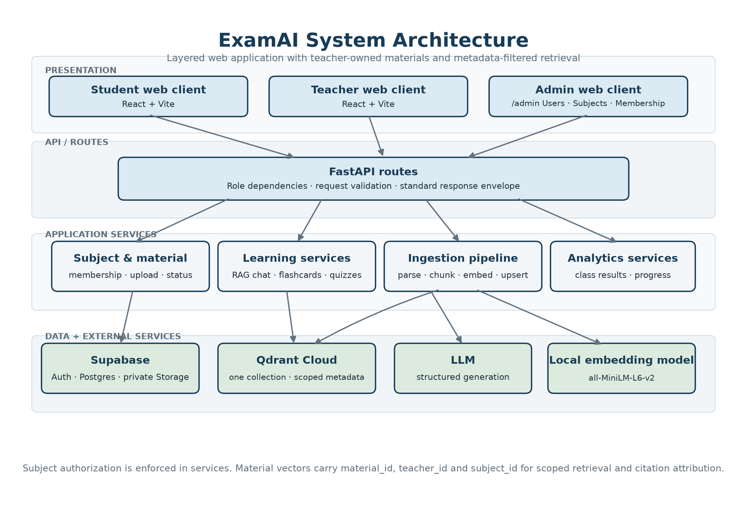
Figure 8.1: System architecture
Layer | Responsibilities
Frontend | Pages, routing, stores, API client, caching, loading and error states
API | Authentication, request validation, standardized response envelope, request IDs
Services | Materials, ingestion, RAG chat, quizzes, flashcards, analytics, administration; all authorization
Relational data | Users, subjects, memberships, materials, quizzes, attempts, decks
Vector + AI | Qdrant filtered retrieval, Gemini structured generation, local embeddings
Storage | Private teacher material files, application configuration

Table 8.1: System architecture layers and responsibilities.

8.2 Class Diagram
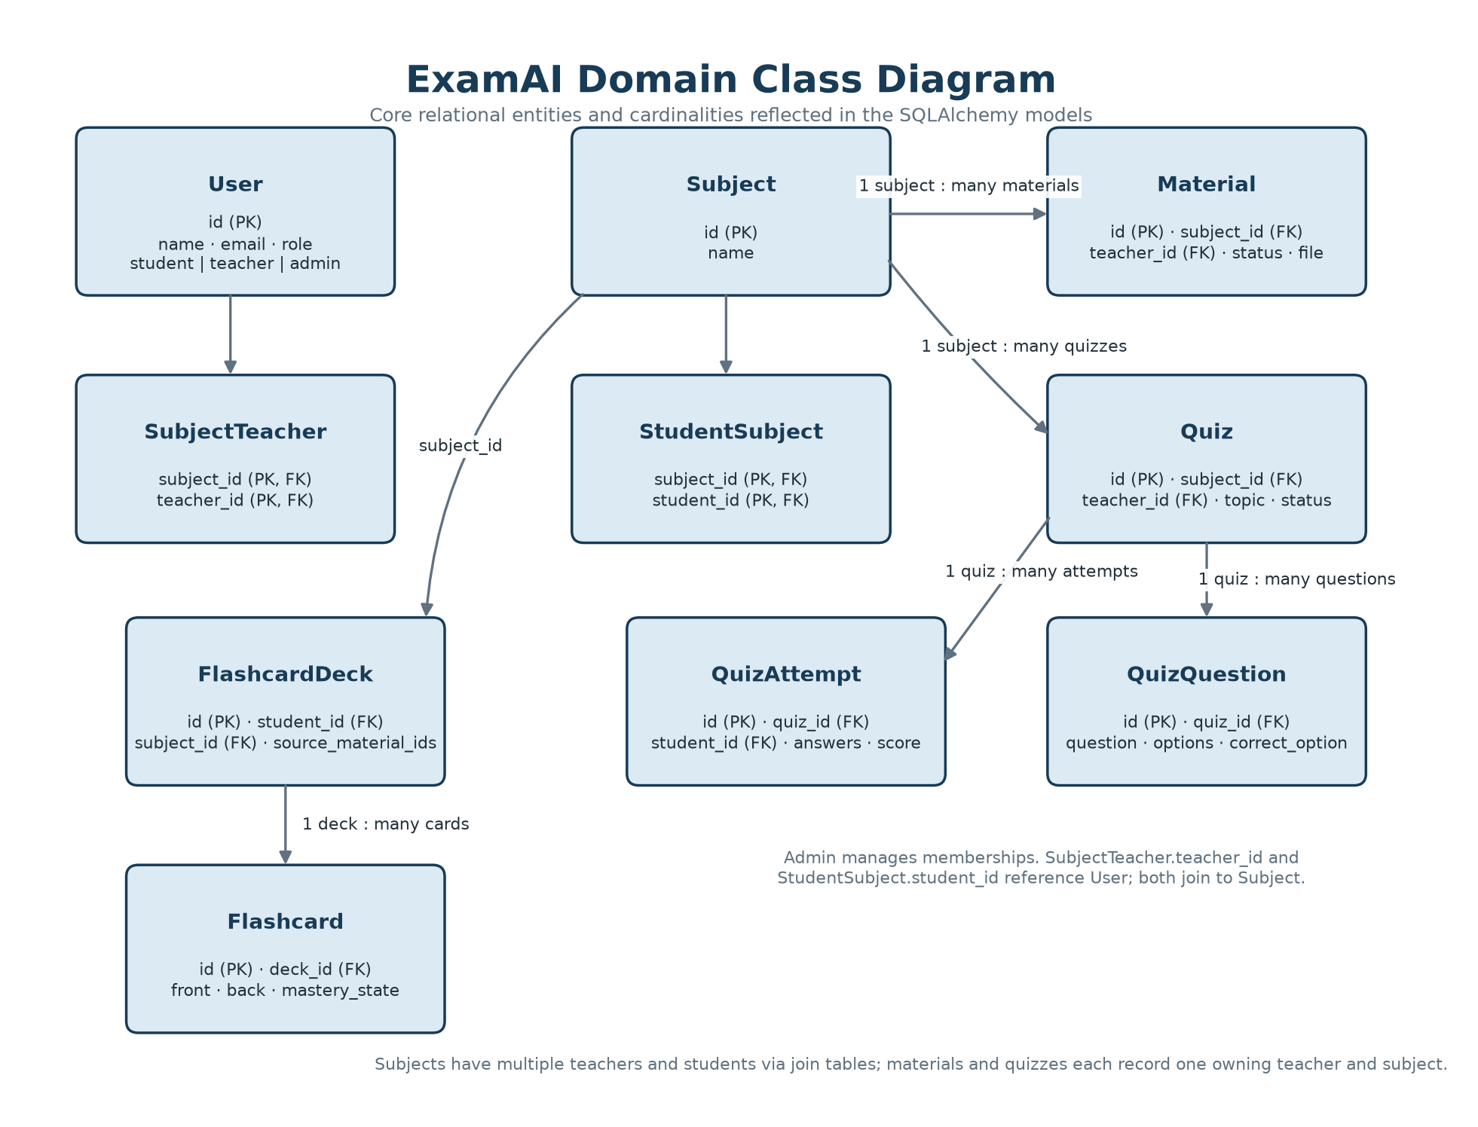
Figure 8.2: Class diagram
The domain centres on Subject: teachers join it through membership, students through enrollment; materials and quizzes belong to exactly one subject and one teacher; attempts belong to one student and one quiz; decks belong to one student and record the source material identifiers used at generation time. The users.role field is three-valued (student, teacher, admin); administrators own no subject workspace and instead manage accounts, subjects, and both join tables through the admin console.

8.3 Use-Case Diagram
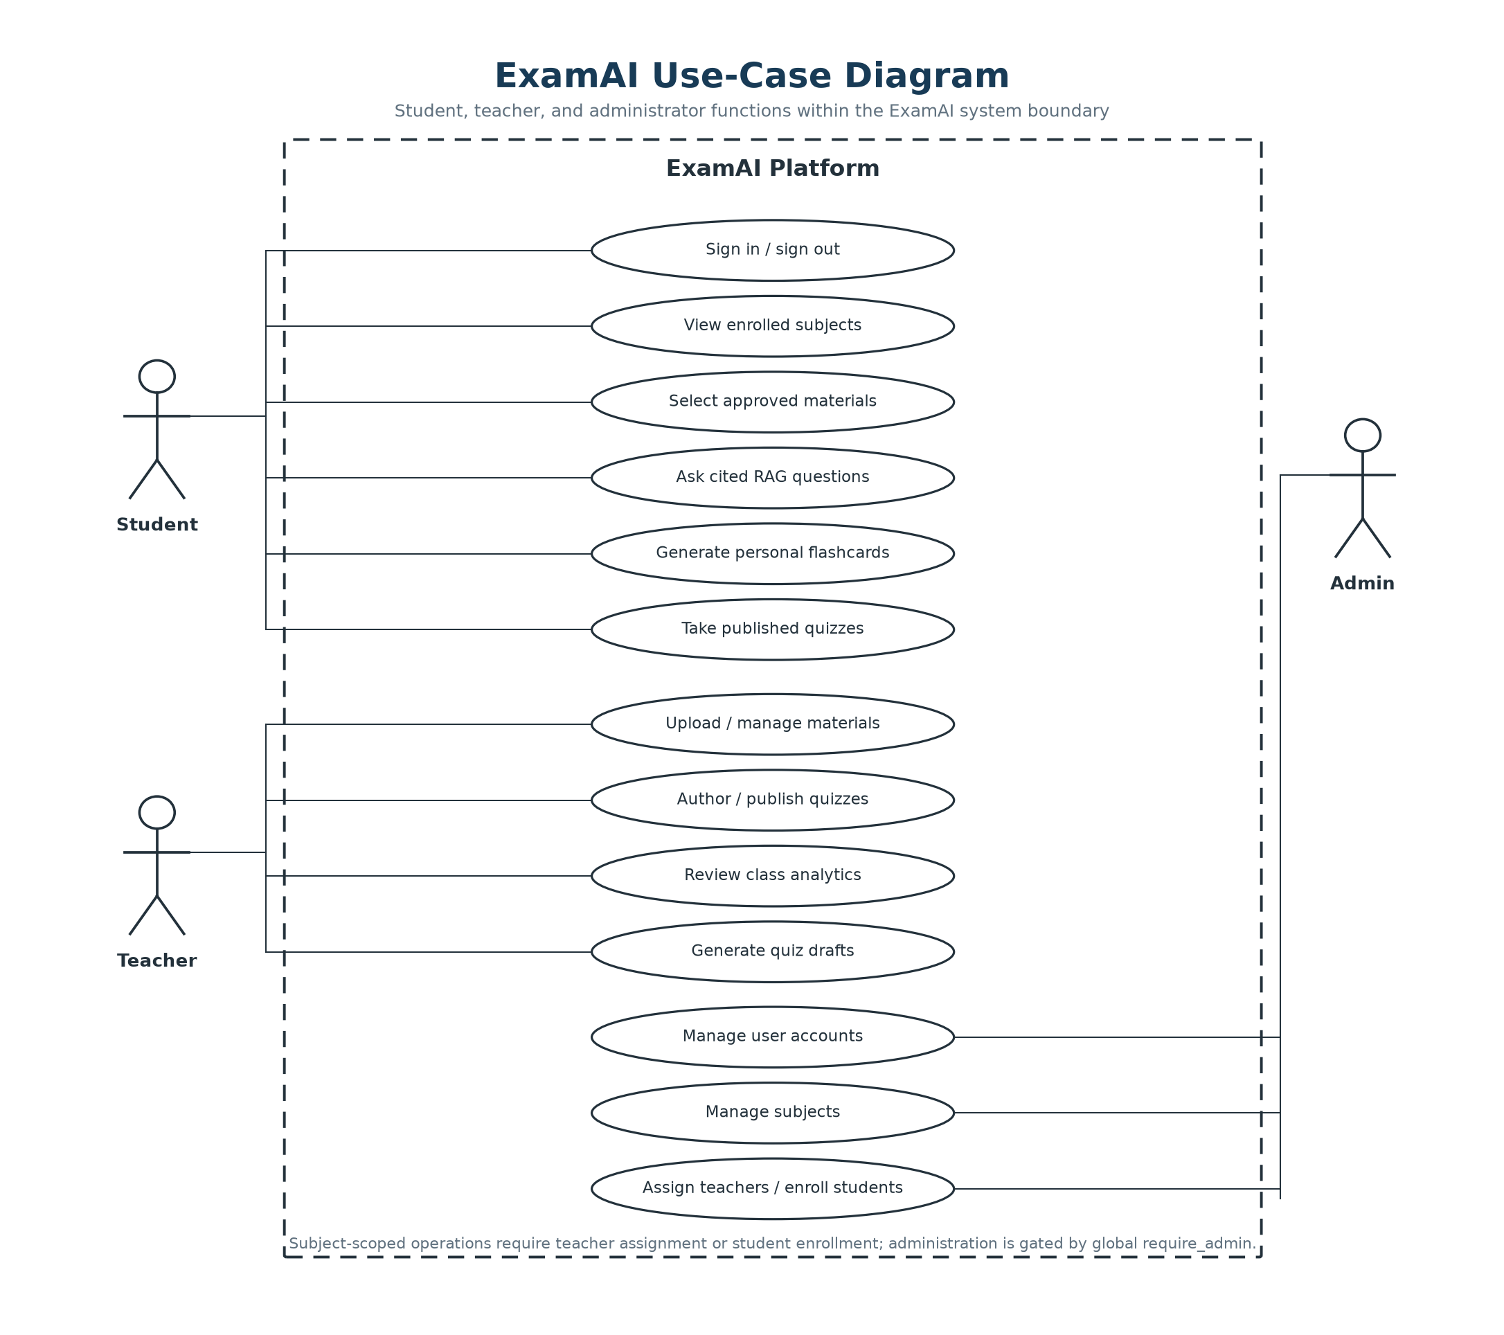
Figure 8.3: Use-case diagram
All three roles authenticate through the same sign-in flow. Subject-scoped requests are authorized against the caller’s teacher assignment or student enrollment before protected data is returned or changed. Administration requests (/api/admin/*, /admin/*) are authorized instead by the global require_admin gate: admins manage users, subjects, and memberships but never bypass subject checks to read study or analytics data.

8.4 Sequence Diagram
The sequence below shows one representative interaction — RAG chat — step by step, since this flow touches every layer of the system in a single user action: the frontend sends subject, selected material identifiers, and a question; the service checks enrollment and validates every identifier in Postgres; the question is embedded; Qdrant is queried with subject-plus-material filters; Gemini receives numbered context; the response is parsed; citation markers are mapped to payload metadata; and the API returns answer text plus citations.
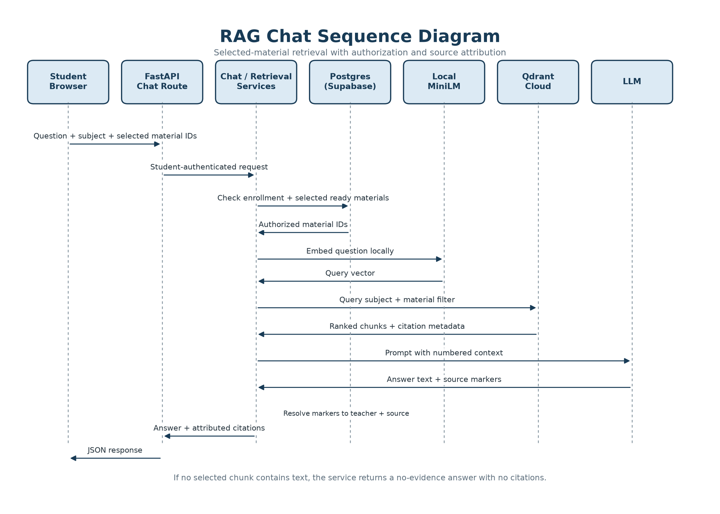
Figure 8.4: RAG chat sequence

8.5 Activity Diagram
Material ingestion begins with a teacher upload. The service validates type and size, stores the private file, creates a processing record, parses the document, normalizes text and metadata, chunks content with format-aware windows, creates embeddings, upserts points in batches, and marks the material ready. A failure marks the material failed and exposes retry; deletion removes both the relational record and its vectors. Version-safe status updates prevent stale work from reviving deleted records.
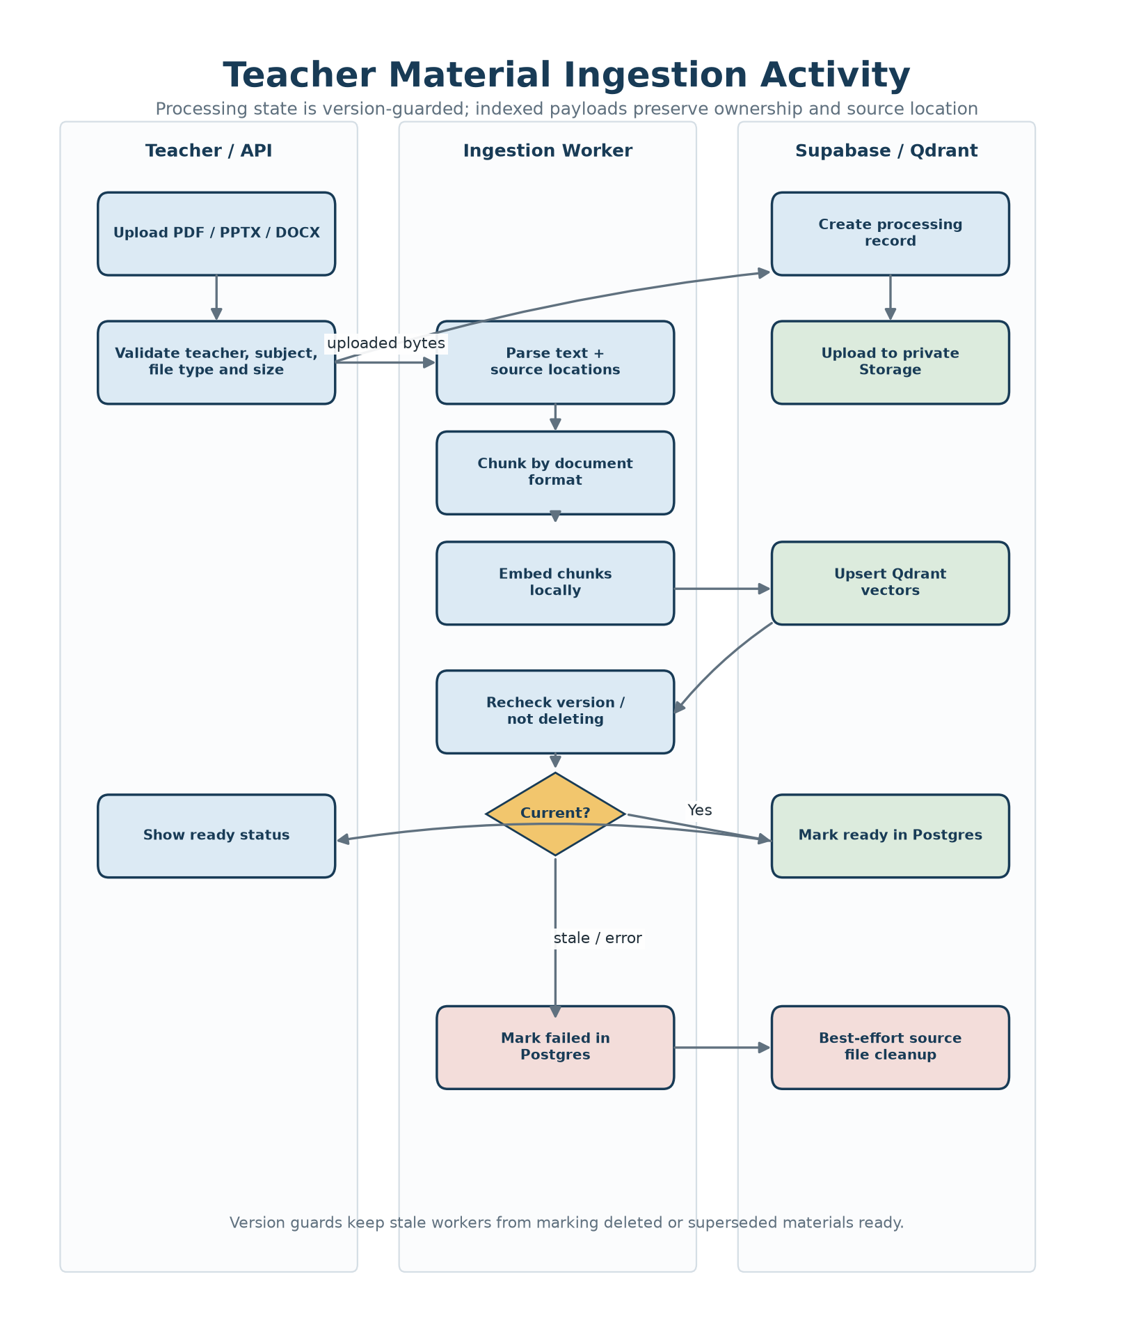
Figure 8.5: Material ingestion activity

8.6 Data Flow Diagram (DFD)

8.6.1 Level 0 DFD
At the highest level, students, teachers, and administrators interact with ExamAI. ExamAI uses Supabase for identity, relational data, and file storage; Qdrant for vector retrieval; and an LLM for structured generation. The system returns study answers, assessments, feedback, decks, and analytics to students and teachers, and managed accounts, subjects, and memberships to administrators.
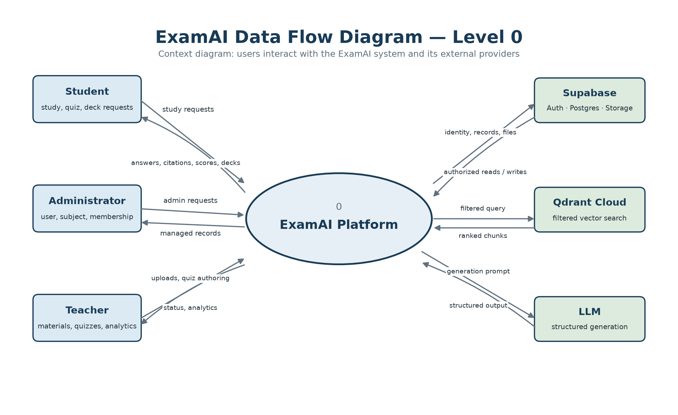
Figure 8.6.1: Level 0 DFD

8.6.2 Level 1 DFD
The level-one diagram follows the implemented learning workflow: teachers prepare materials and shared quizzes, students study and complete assessments, and quiz results feed class analytics. Administration manages users and subject membership, and students receive answers, citations, scores, and personal flashcard decks.
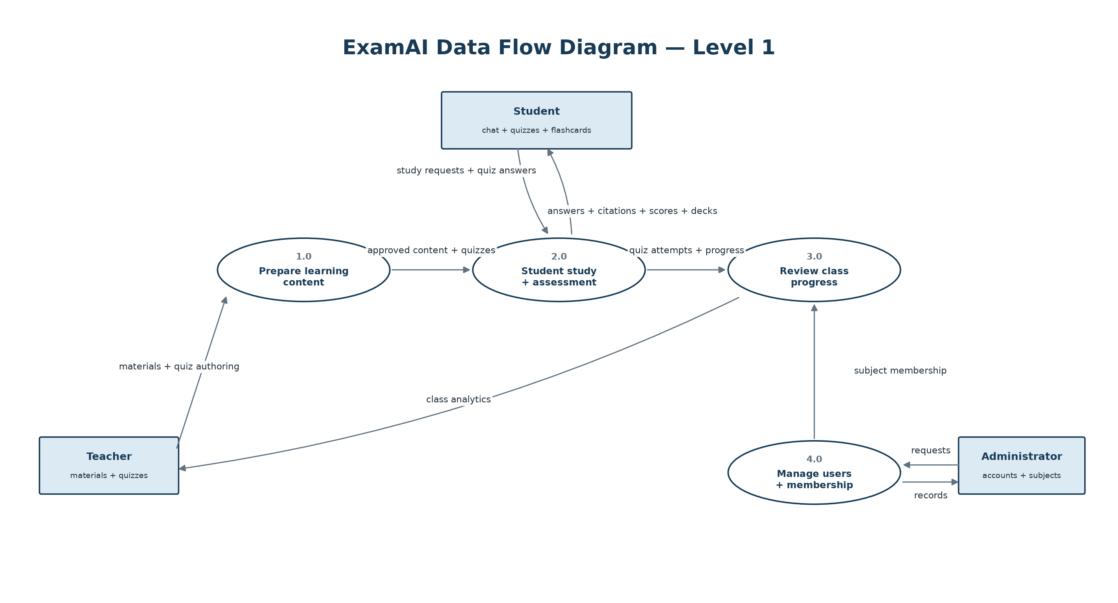
Figure 8.6.2: Level 1 DFD

8.7 Data Model
The relational model contains users, subjects, subject–teacher membership, student–subject enrollment, materials, quizzes, quiz questions, quiz attempts, flashcard decks, and flashcards. A material belongs to one teacher and one subject; a subject may have multiple teachers. A quiz is teacher-authored and subject-scoped; an attempt belongs to one student and one quiz. A flashcard deck belongs to one student and records its source material identifiers. The per-session material selection is intentionally request-time data, not a table — this keeps "adjustable per session" true at the data layer.

CHAPTER 9
RESULT AND DISCUSSION

▪ LOGIN AND ROLE-BASED ACCESS
▪ STUDENT DASHBOARD AND SUBJECT VIEW
▪ RAG CHAT WITH MATERIAL SCOPE AND CITATIONS
▪ QUIZ TAKING AND FEEDBACK
▪ FLASHCARD GENERATION AND STUDY
▪ TEACHER MATERIAL MANAGEMENT
▪ TEACHER QUIZ AUTHORING AND PUBLISHING
▪ TEACHER ANALYTICS AND STUDENT PROGRESS
▪ ADMIN CONSOLE AND MEMBERSHIP MANAGEMENT
▪ SECURITY AND RELIABILITY RESULTS
▪ OVERALL SYSTEM PERFORMANCE

CHAPTER 9 RESULT AND DISCUSSION
ExamAI was built, tested, and verified end to end as a local prototype: every feature described in the earlier chapters works as designed against the offline test suites (103 backend, 84 frontend) plus manual end-to-end passes over a local run. This chapter walks through the finished screens in the order a user meets them, with a short discussion of each one. (Online deployment is planned but not yet carried out, so all screens below are captured from the local build running against seeded demo accounts — the names visible are seed data, not real users.)

9.1 Login and Role-Based Access
A provisioned user logs in with email and password; the backend derives the role (student, teacher, or admin) from the stored profile and the frontend routes to the student, teacher, or admin (/admin/users) workspace accordingly. The sign-in form offers email and password fields only — there is no signup link and no client-side role selector, so an unregistered email is rejected and an authenticated user can never reach the other roles' routes.
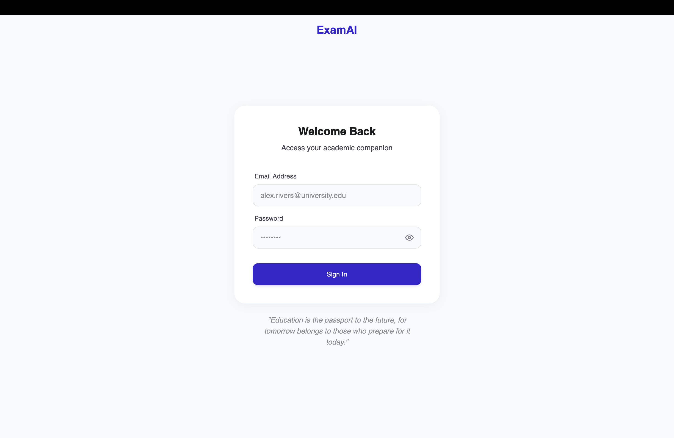
Figure 9.1: Sign-in form — email and password only, no signup or role selector.

9.2 Student Dashboard and Subject View
The student home opens with a study hero panel leading into chat, followed by quick stats (quizzes taken, weak topics, average score) and enrolled-subject cards showing each subject's teachers and the student's progress. The demo account in Figure 9.2 shows three enrolled subjects — including multi-teacher subjects — with per-subject progress bars. The Resources view (Figure 9.3) states the ownership promise directly — "Materials approved by your teachers, grouped by course" — with browse-by-course pills, filter-by-teacher checkboxes, a Recently Added strip, and an All Materials table (name, course, date, size, owner). Only ready materials appear in this student-facing list; processing or failed items remain a teacher-side concern.
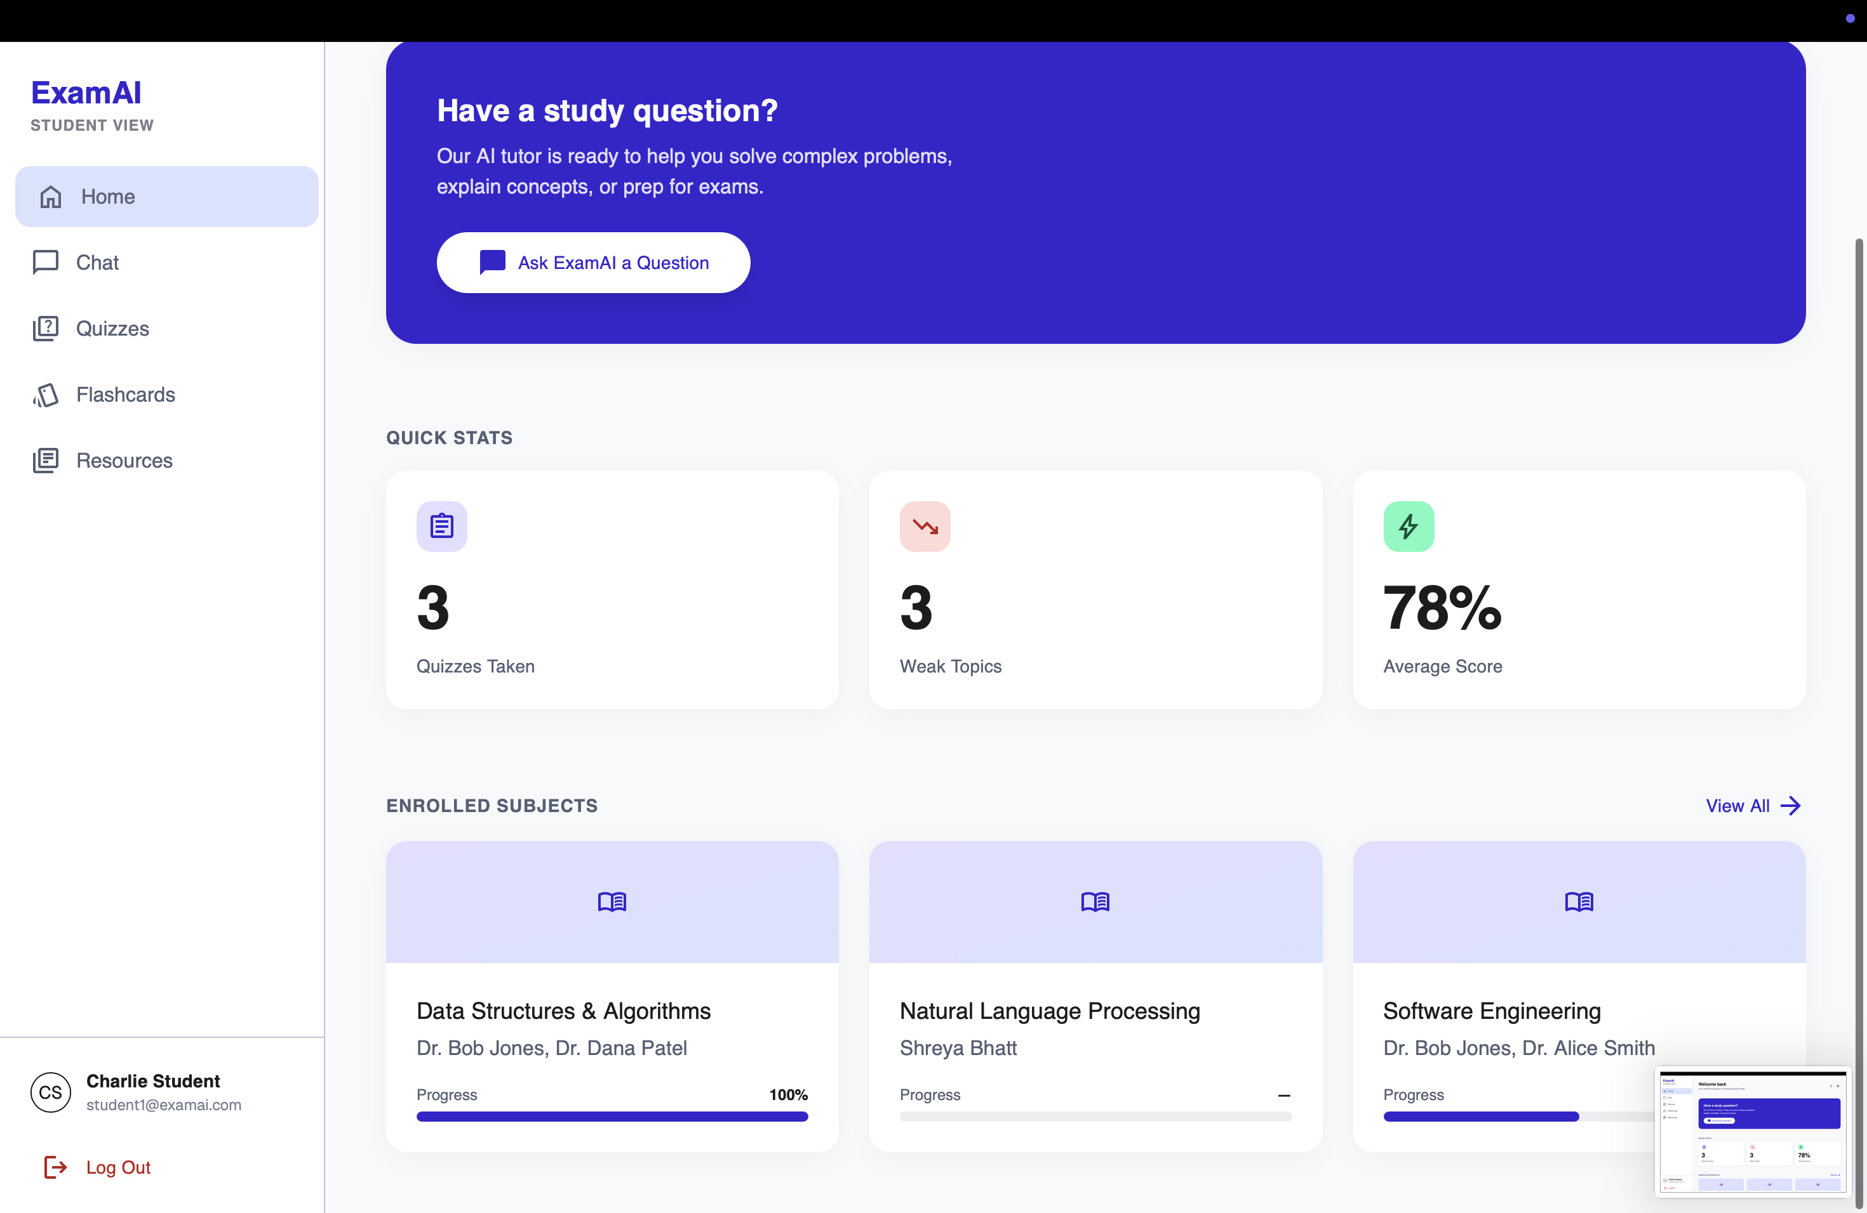
Figure 9.2: Student dashboard — study hero, quick stats, and enrolled subjects with teachers and progress.
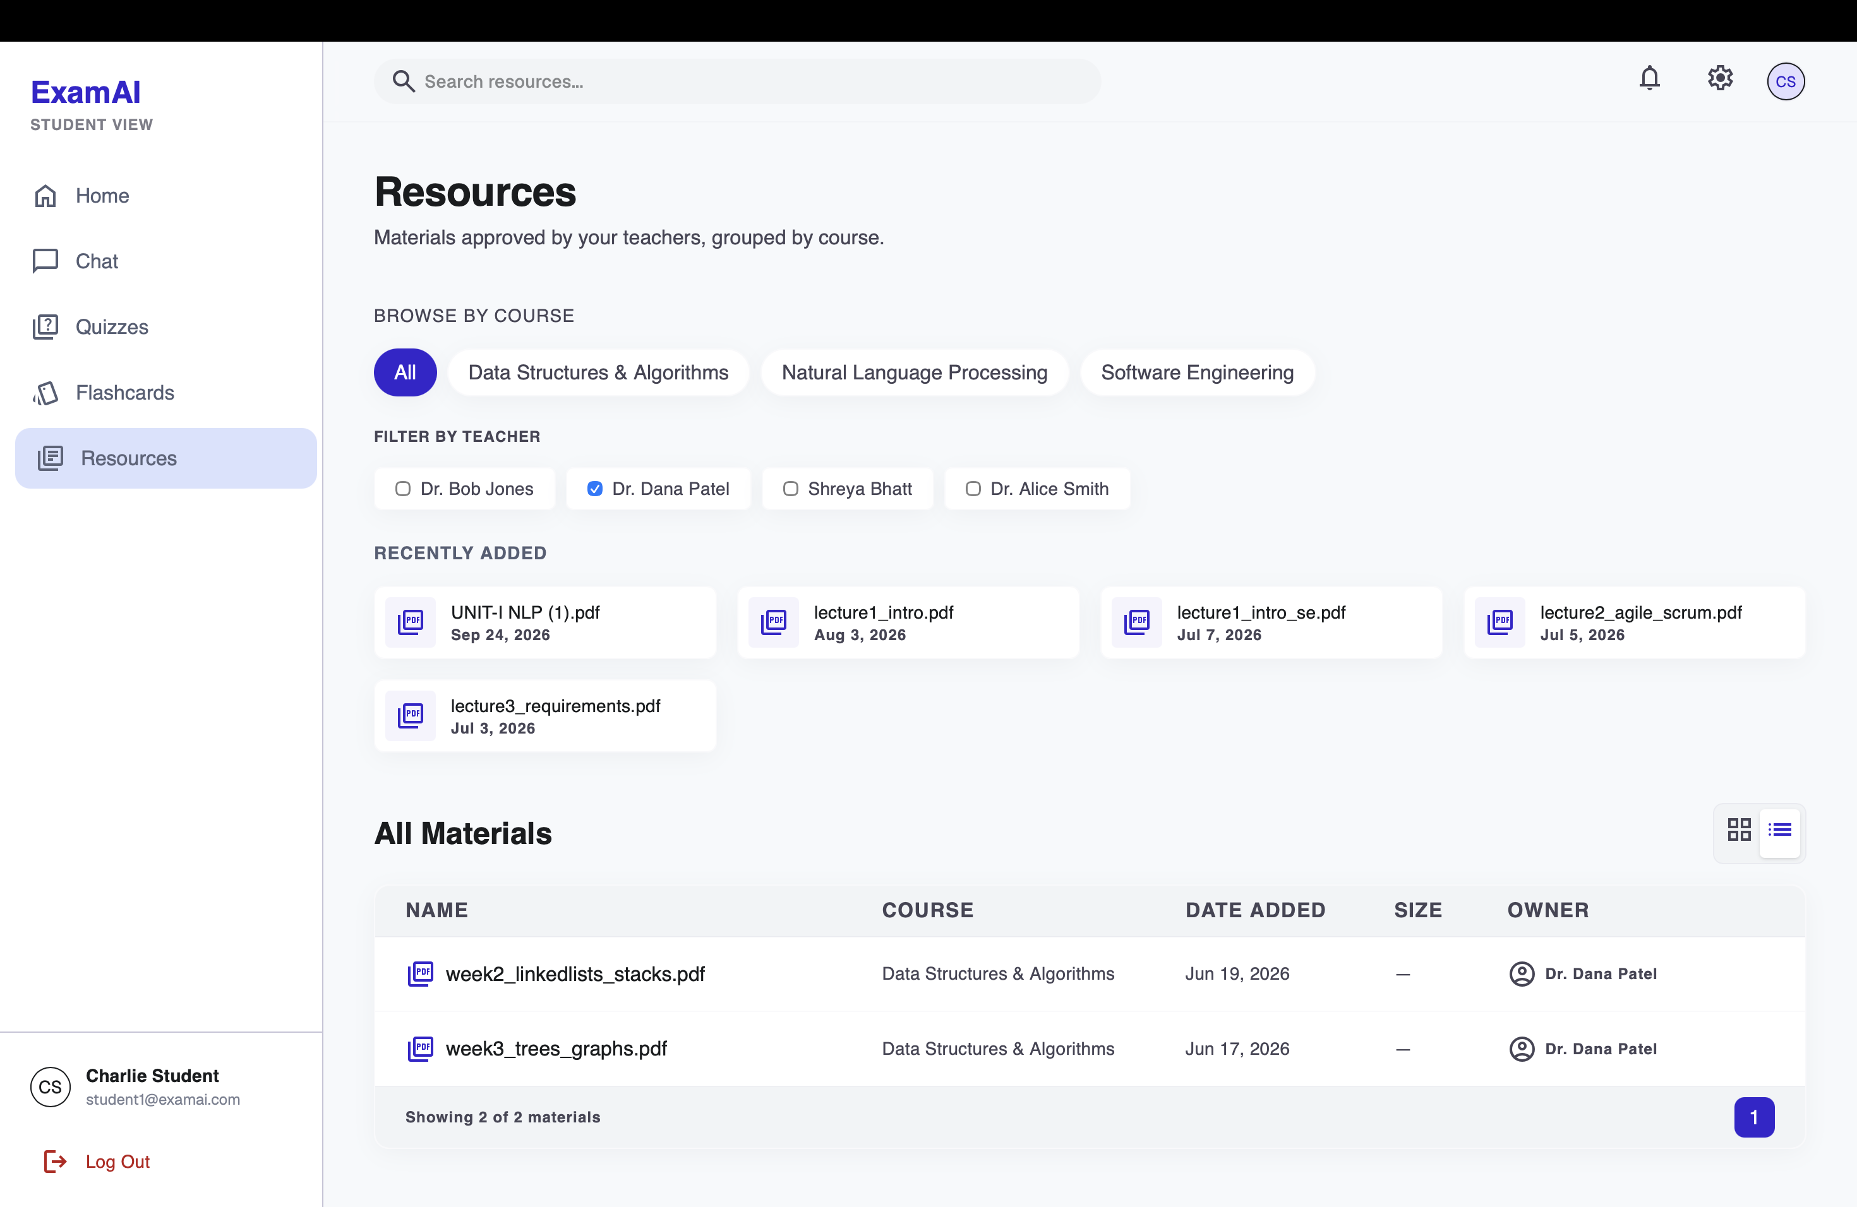
Figure 9.3: Subject resources — approved materials grouped by teacher with filter; only ready items are visible to students.

9.3 RAG Chat with Material Scope and Citations
The chat view pairs the conversation with a visible study-materials panel: the student ticks which ready materials should ground the session (grouped under the owning teacher's name), with the active count always shown. Answers render with numbered citation markers; hovering a marker reveals the teacher and filename, and a citation footer under each answer names the source explicitly. Figure 9.4 demonstrates both halves of the attribution guarantee: the in-corpus question ("What is NLP") receives a grounded answer citing the teacher's file, while the off-corpus question ("who is Donald trump") is refused with "The provided context is insufficient…" instead of hallucinated — the system answers only from approved material.
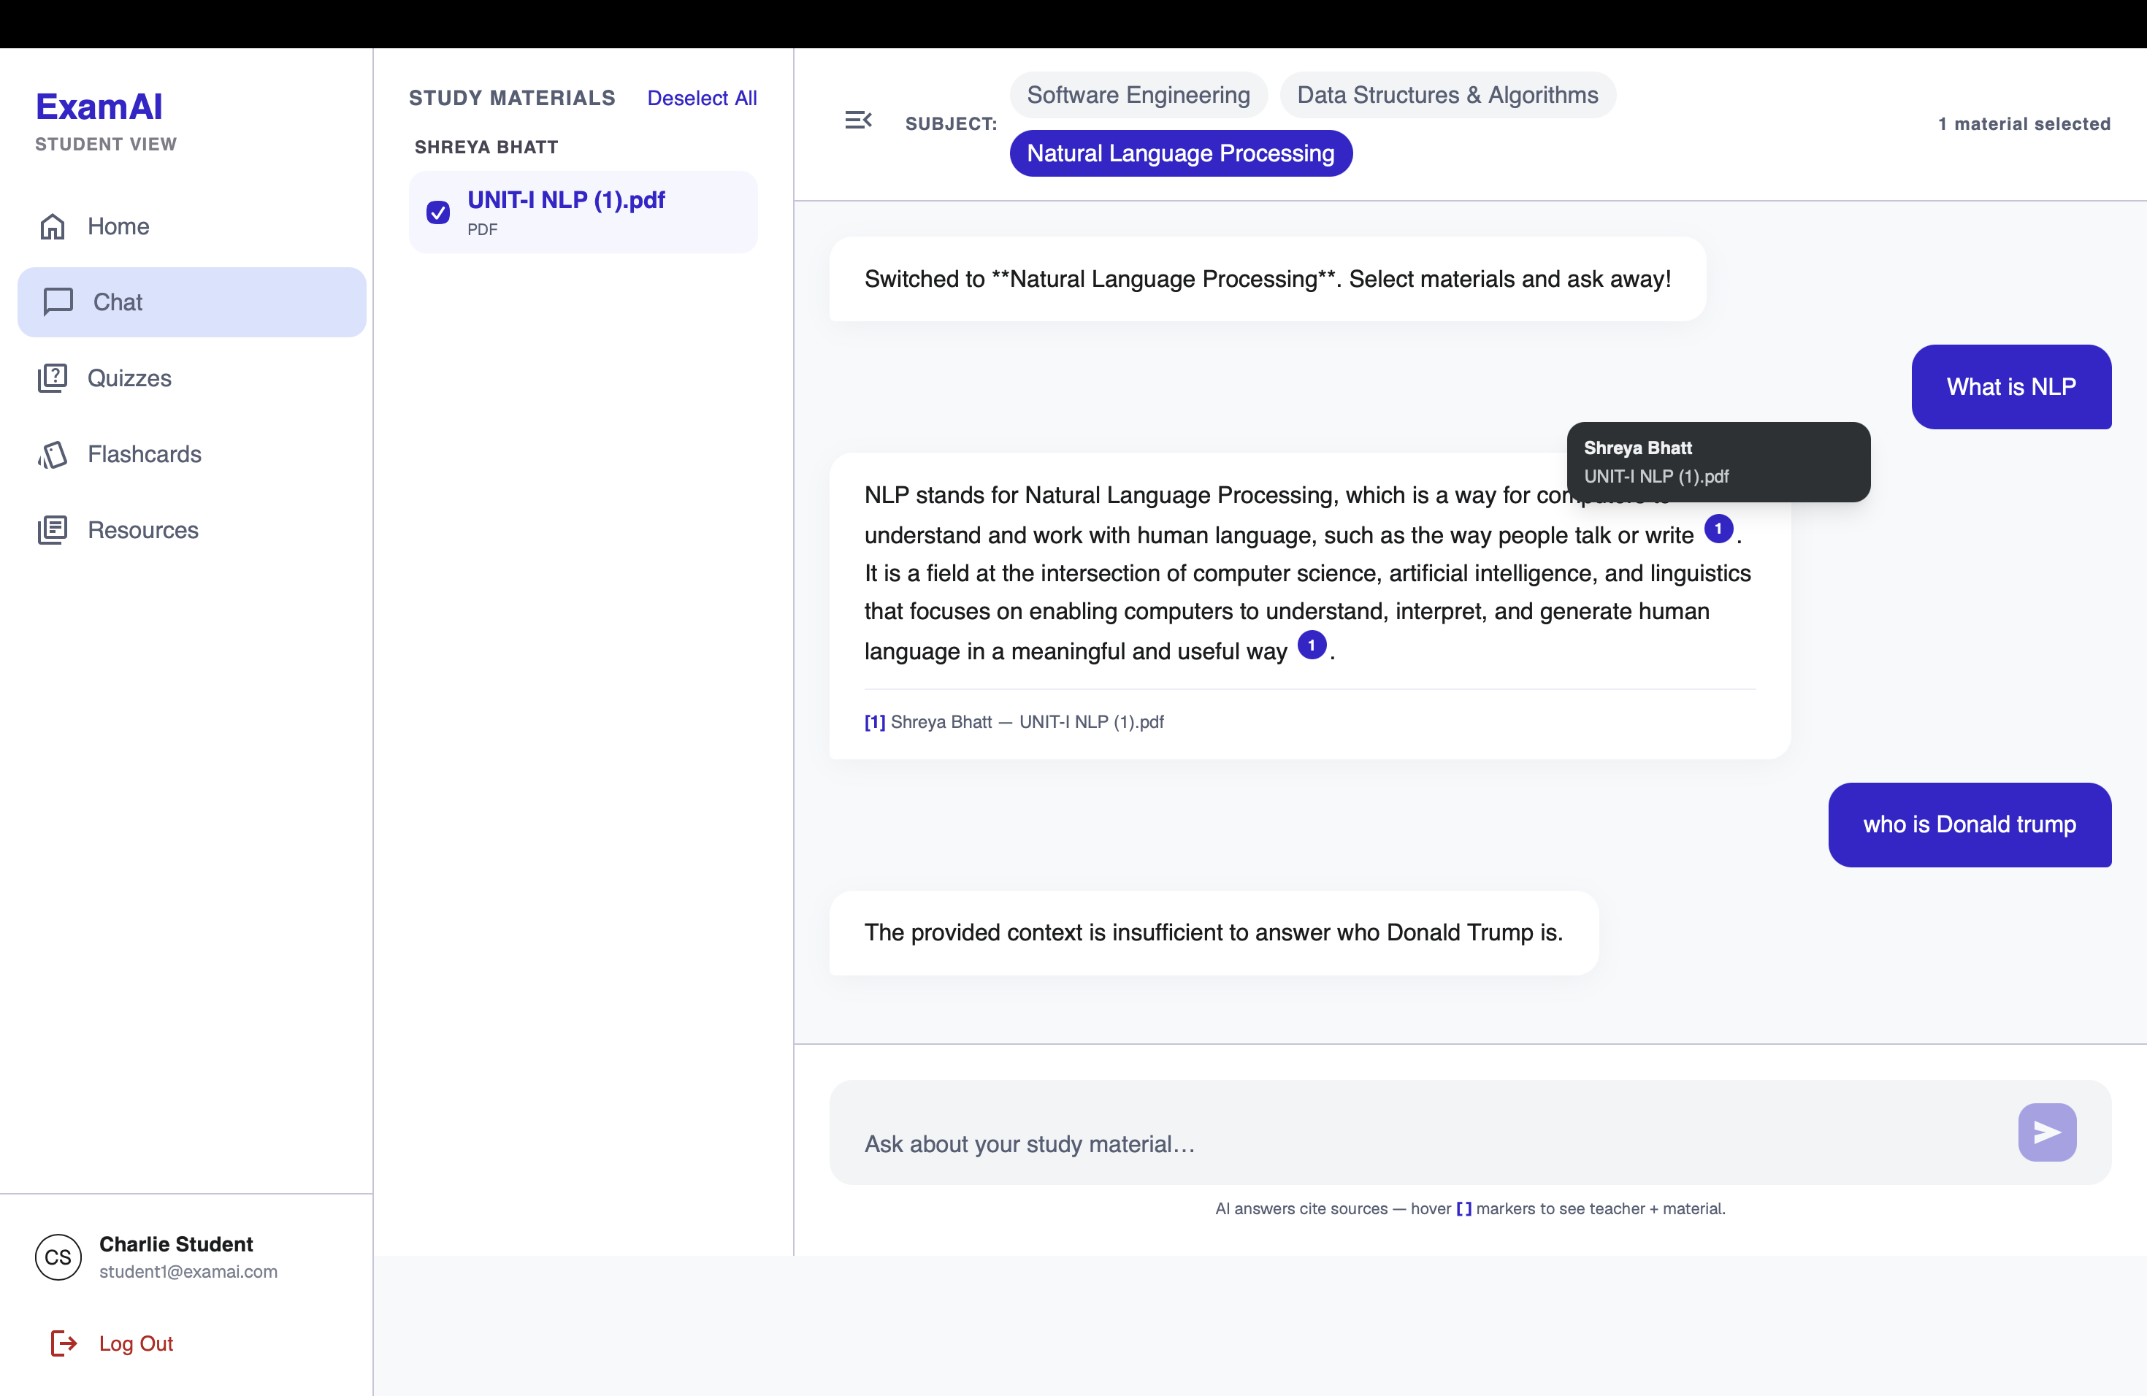
Figure 9.4: RAG chat — per-session material scope, numbered citations with teacher/file tooltip, and grounded refusal of an off-corpus question.

9.4 Quiz Taking and Feedback
The quiz list (Figure 9.5) shows four published quizzes across the student's subjects, each naming its authoring teacher: completed ones carry a Completed badge with the score and a View Results action, while the unattempted one offers Start Quiz. Taking a quiz (Figure 9.6) presents one question at a time under a visible countdown timer with Previous/Next navigation and progress dots. On submission the server grades the attempt and returns a grade card (Figure 9.7 shows a D at 50%, 3 of 6 correct) with an "Areas to Review" breakdown by topic tag (SDLC 67%, Requirements 33%), followed by a full question review (Figure 9.8) marking each response — the student's wrong pick highlighted in red against the correct choice in green, as seen in Q2 where the chosen distractor and the correct answer are shown side by side. Re-submitting an attempt is idempotent — the score is not duplicated.
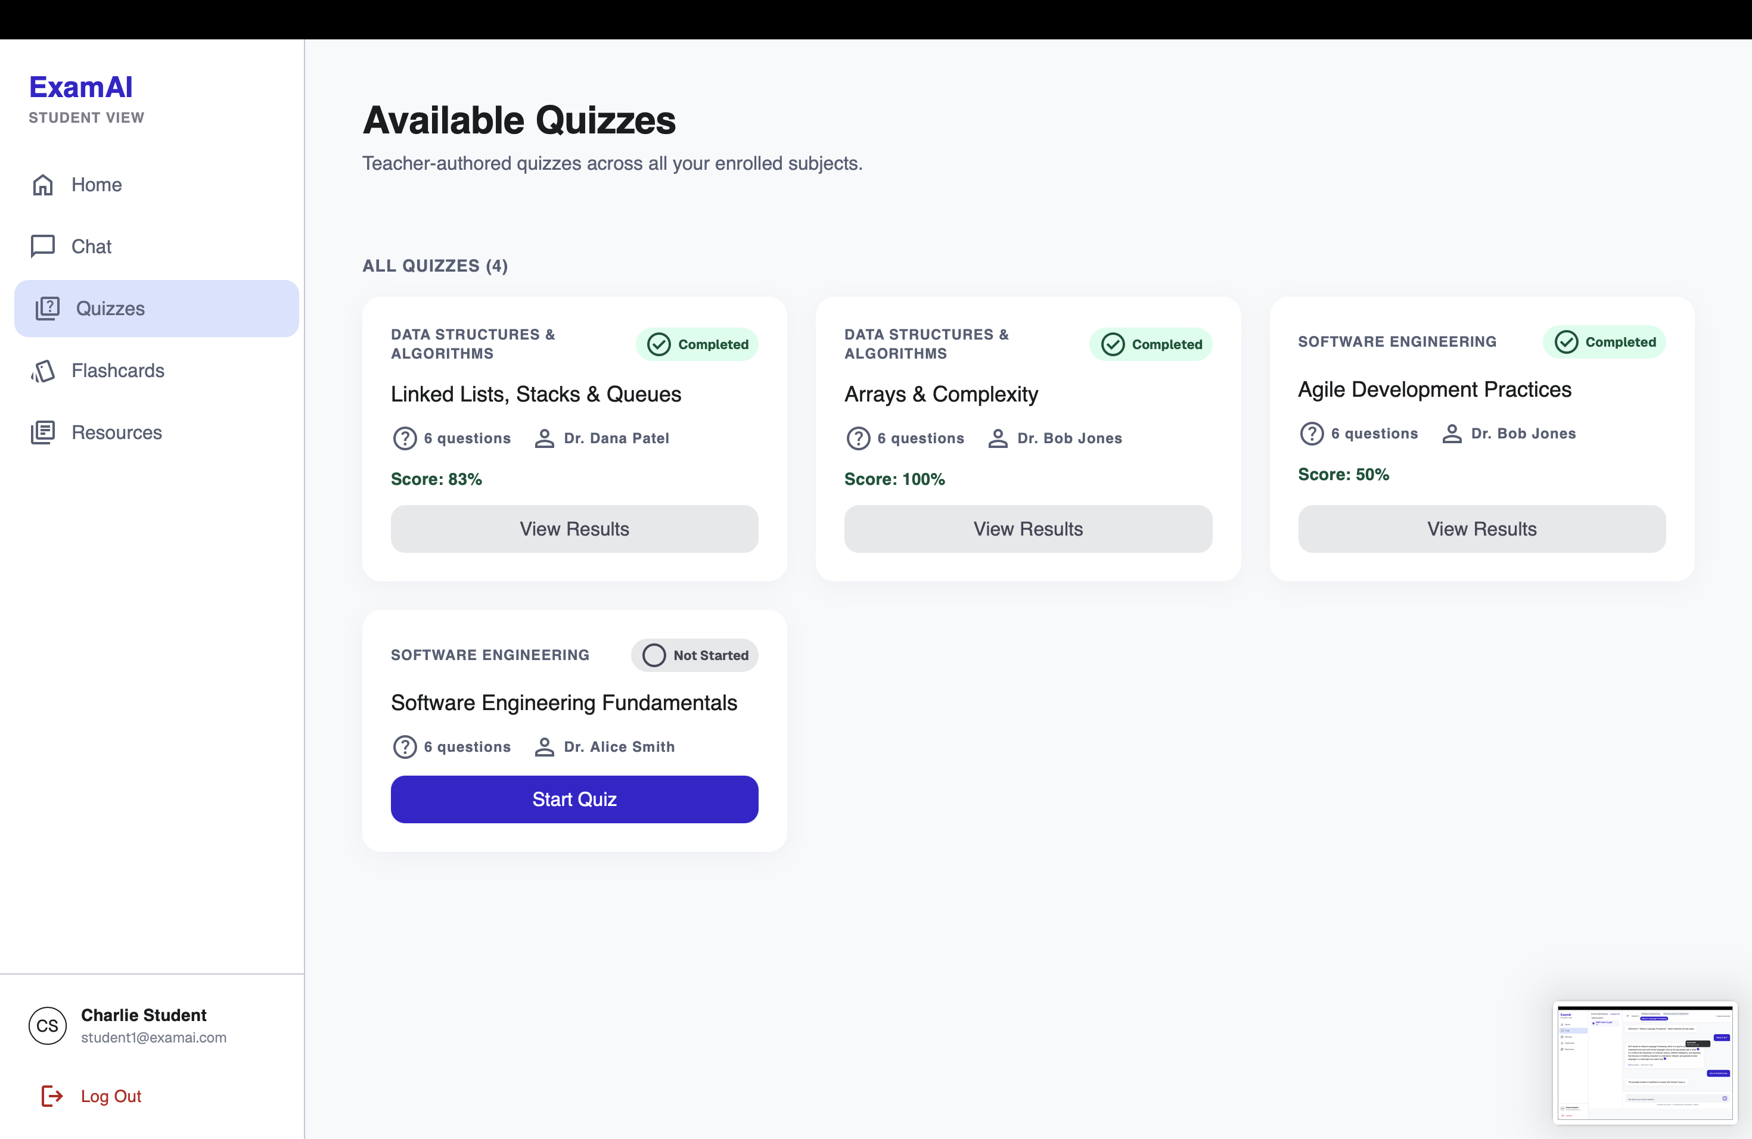
Figure 9.5: Published quiz list with completed scores.
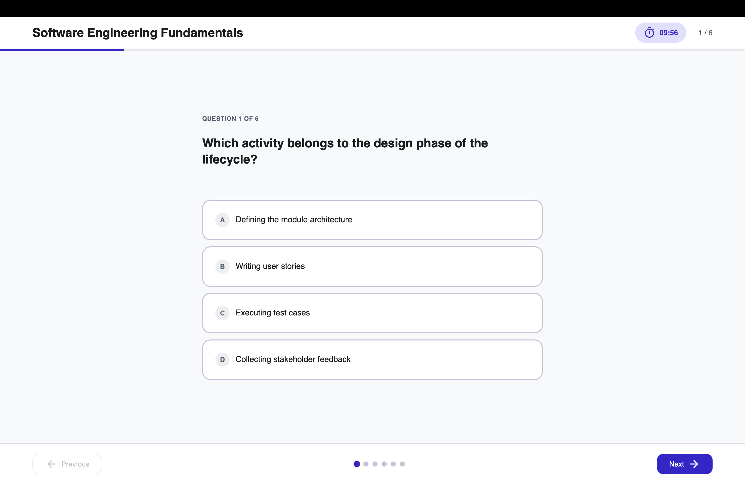
Figure 9.6: Quiz taking — one question at a time under a visible countdown with Previous/Next navigation.
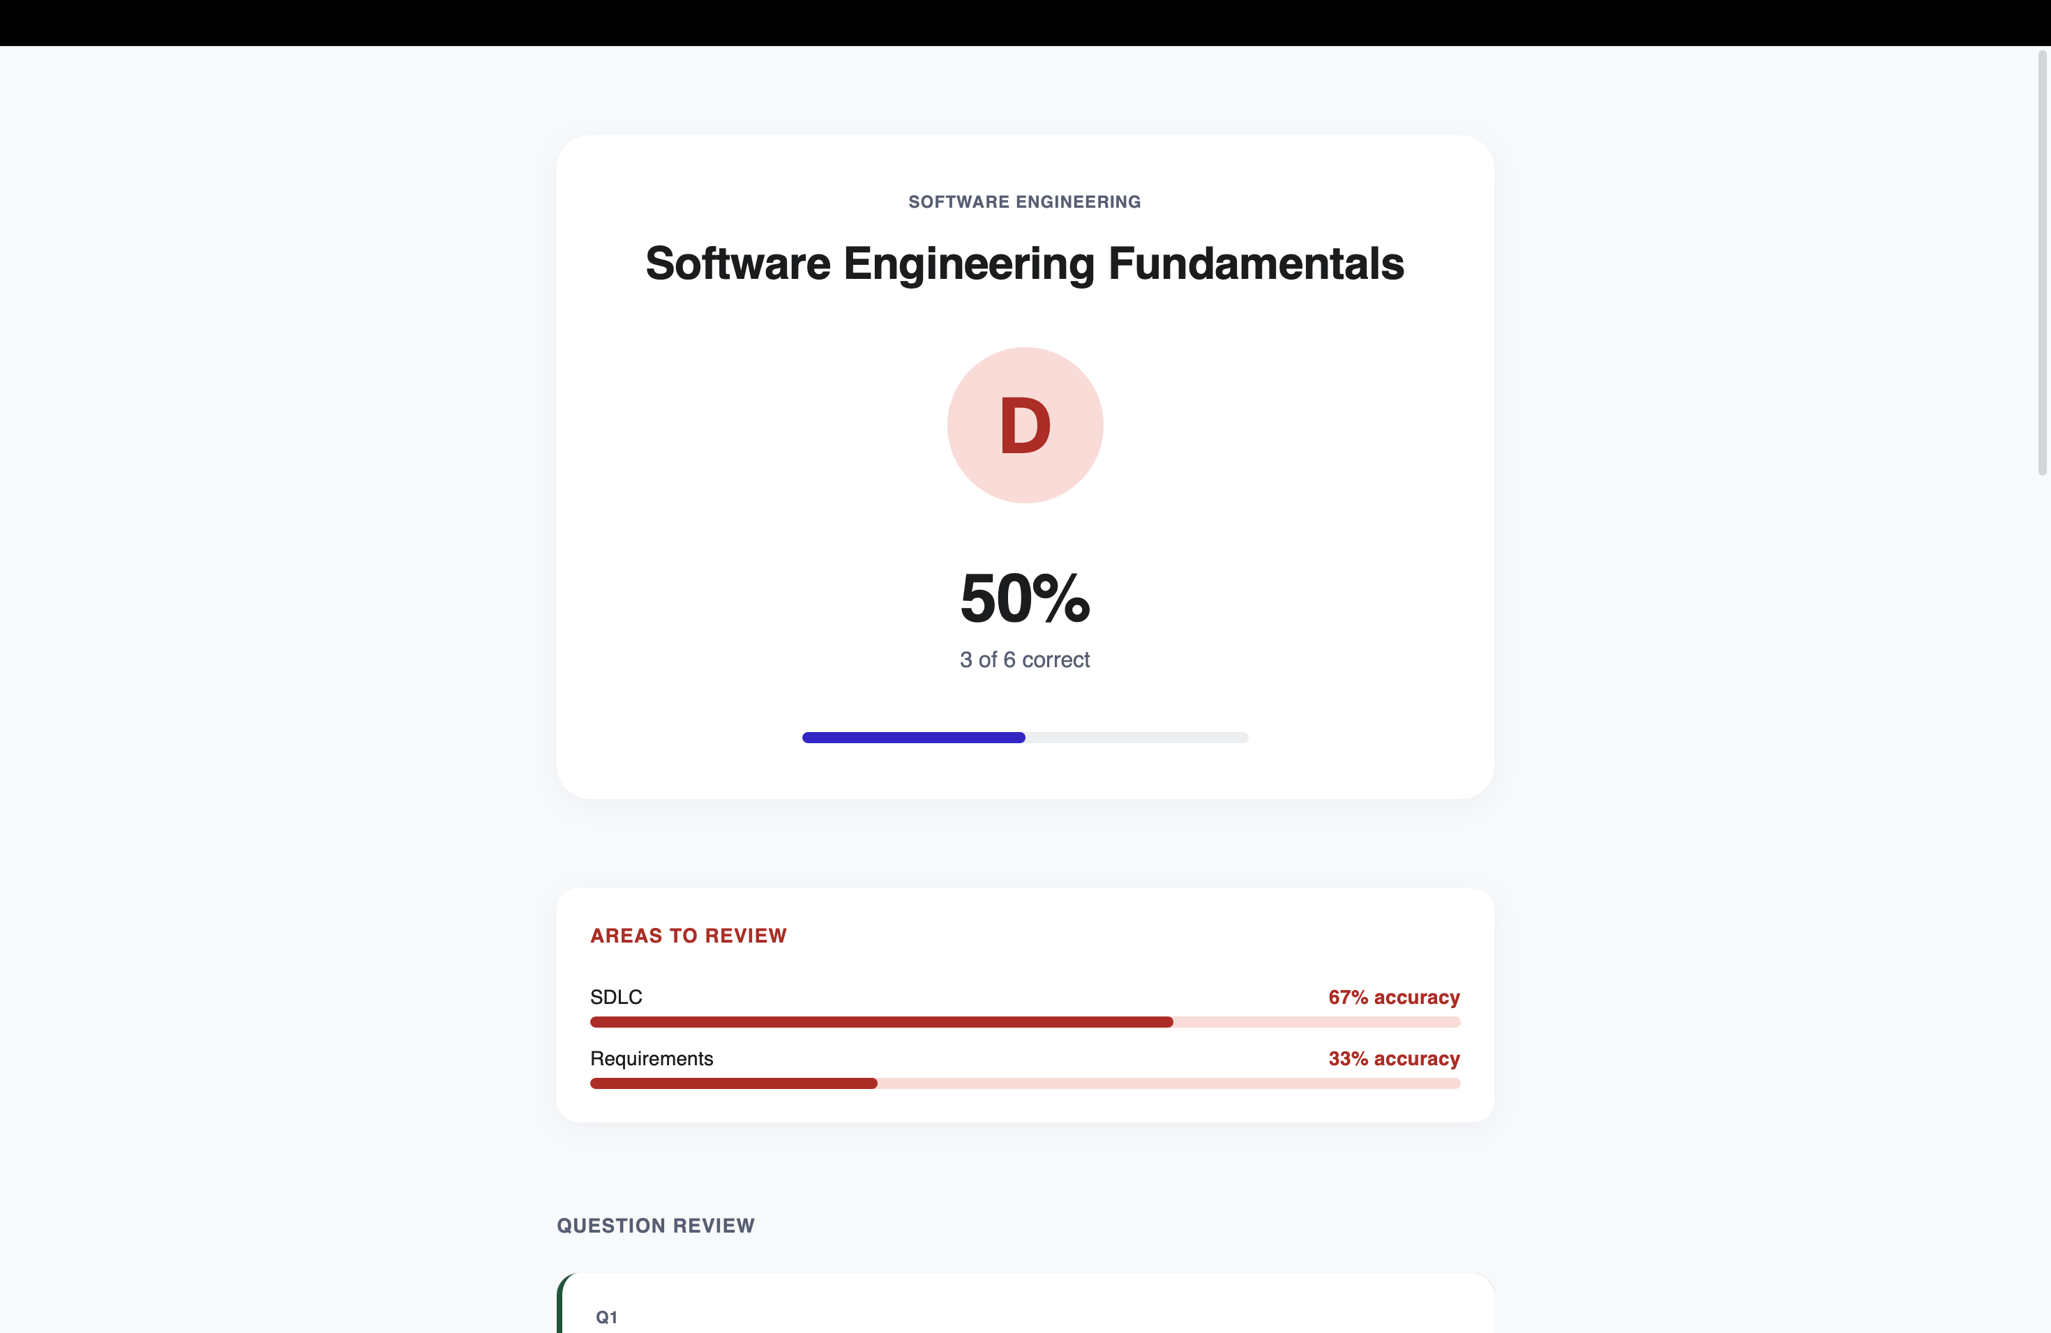
Figure 9.7: Result card — grade, score, and per-topic areas to review.
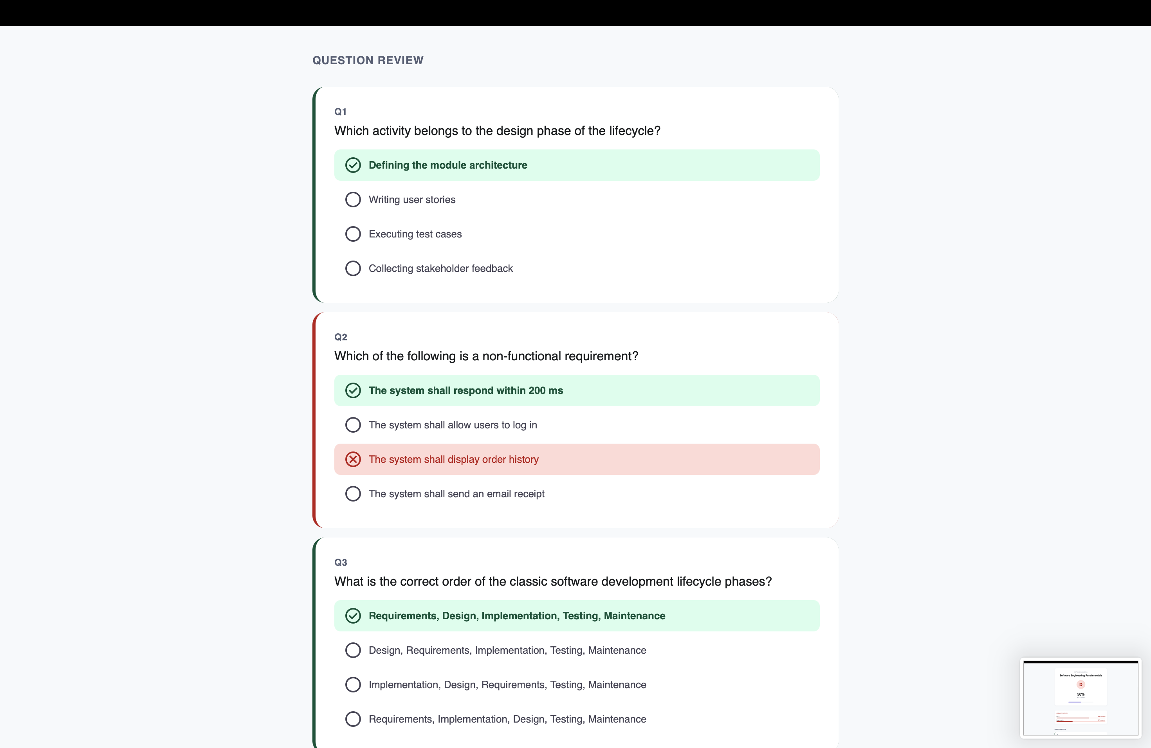
Figure 9.8: Question review — per-question correct/wrong marking against the correct choice.

9.5 Flashcard Generation and Study
From any selected material set the student generates a named deck via the Generate New Deck action; the deck list (Figure 9.9) shows two personal decks with card counts, mastered counts, and mastery bars (8 cards / 4 mastered / 50%; 10 cards / 3 mastered / 30%). Cards are studied in a flip view (Figure 9.10 shows card 1 of 8 in "Data Structures Quick Cards" with tap-to-reveal) and marked still-learning or mastered, moving the card between new, learning, and mastered states. Decks are personal to the student and record the source material identifiers used at generation, so a deck can always be traced back to what it was built from.
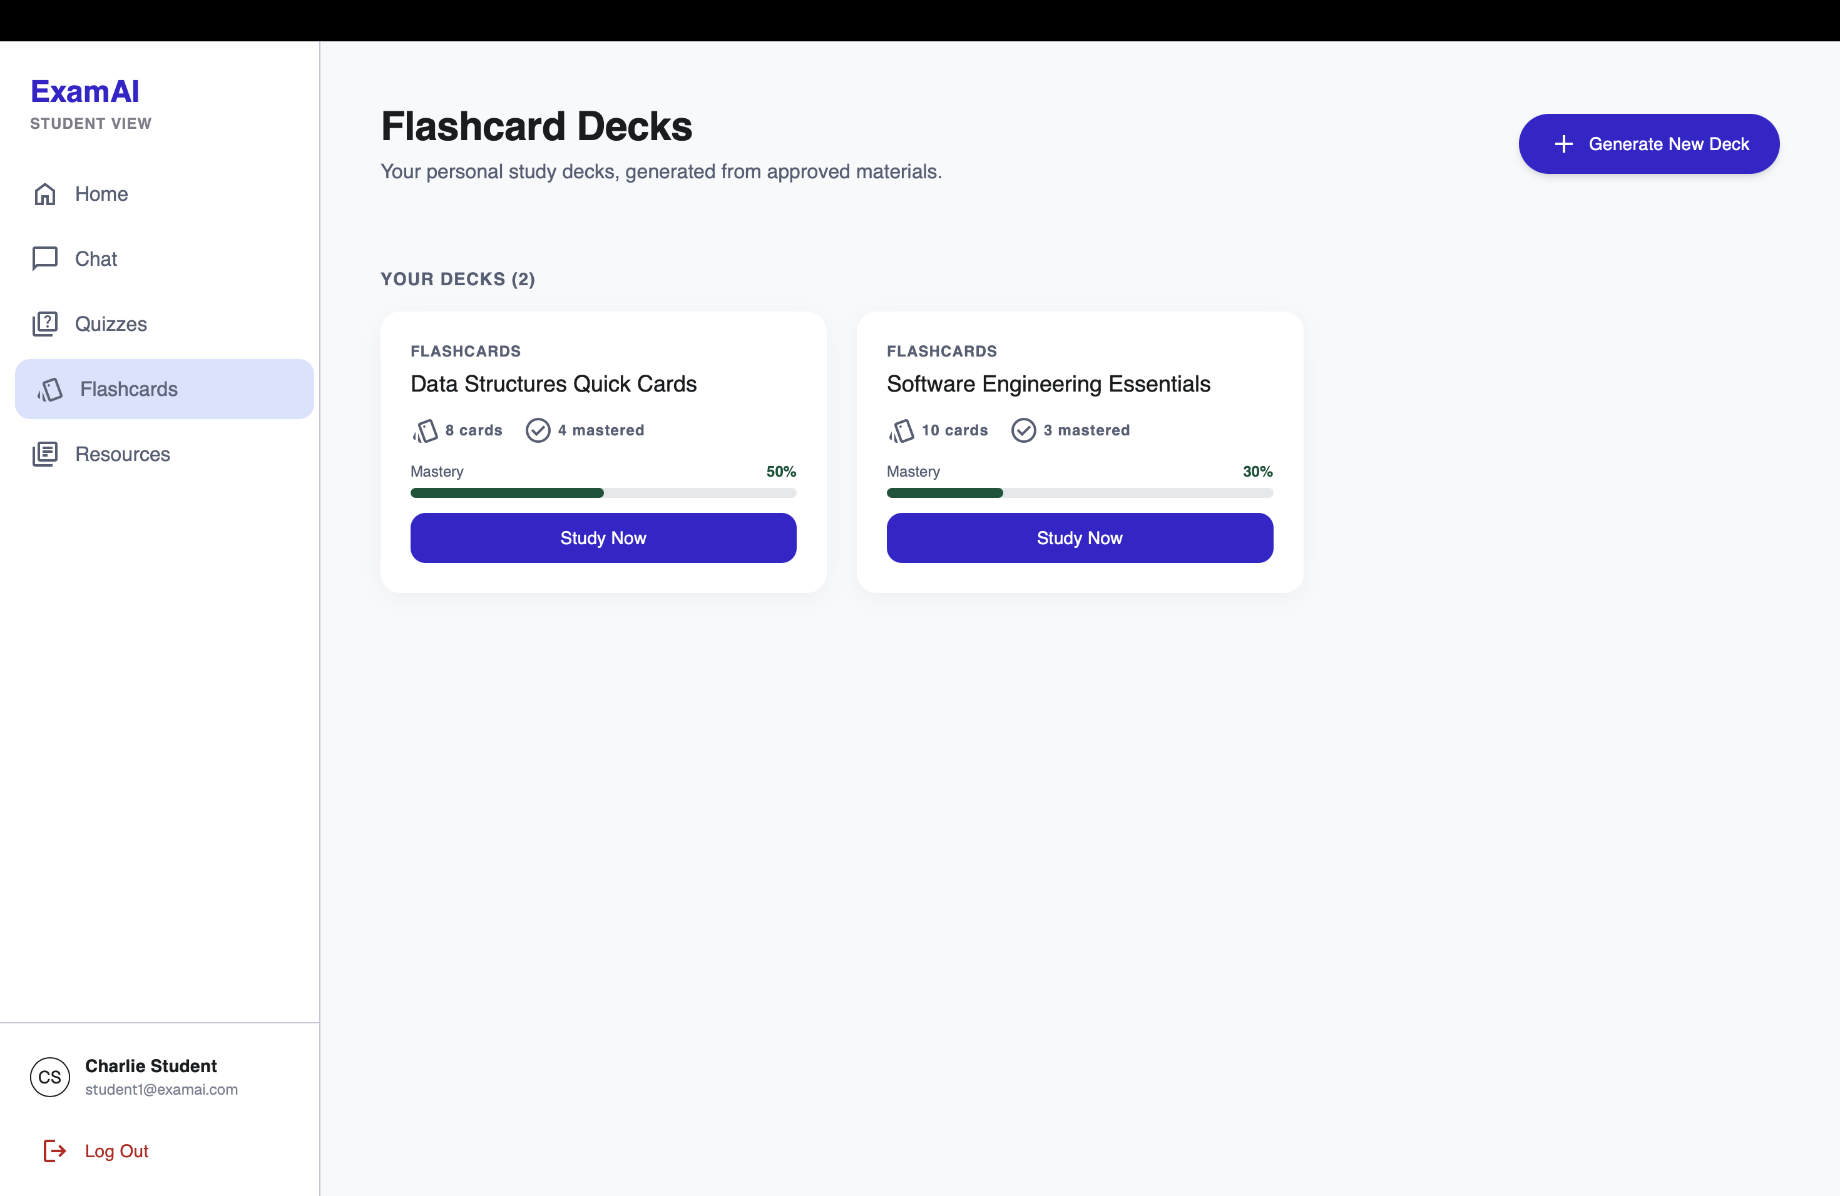
Figure 9.9: Flashcard deck list with mastery progress.
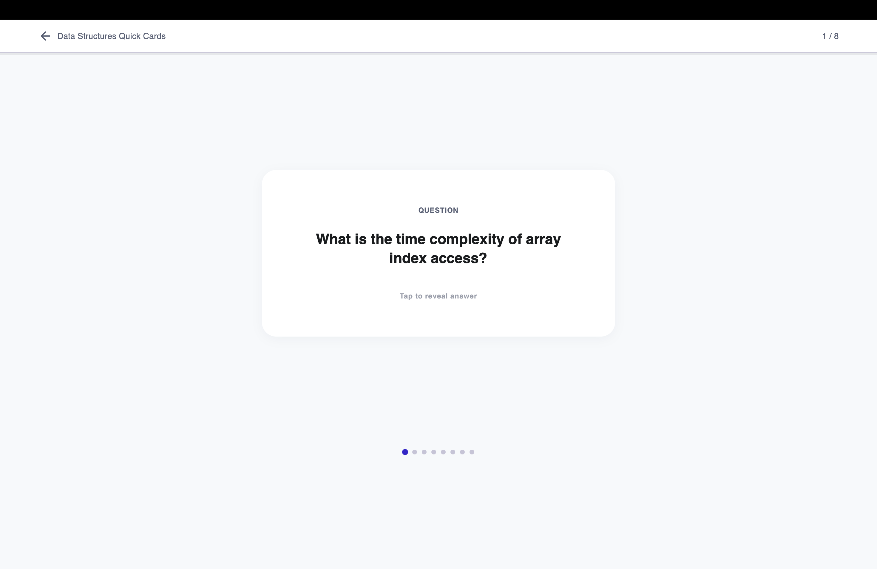
Figure 9.10: Flip-study view — question front with answer reveal and mastery controls.

9.6 Teacher Material Management
The teacher materials view ("Resources & Materials") states its sharing rule directly: "Co-teacher materials are visible but read-only." A drag-and-drop upload zone accepts PDF, PPTX, and DOCX with per-subject tabs, and the All Materials table lists file, subject, owner, status, and upload date. The Owner column distinguishes the teacher's own files ("You", editable) from a co-teacher's (visible only), and the captured rows show Ready badges — the processing and failed states with retry, plus deletion, are handled by the same pipeline (Section 8.5) and covered in testing (Chapter 7).
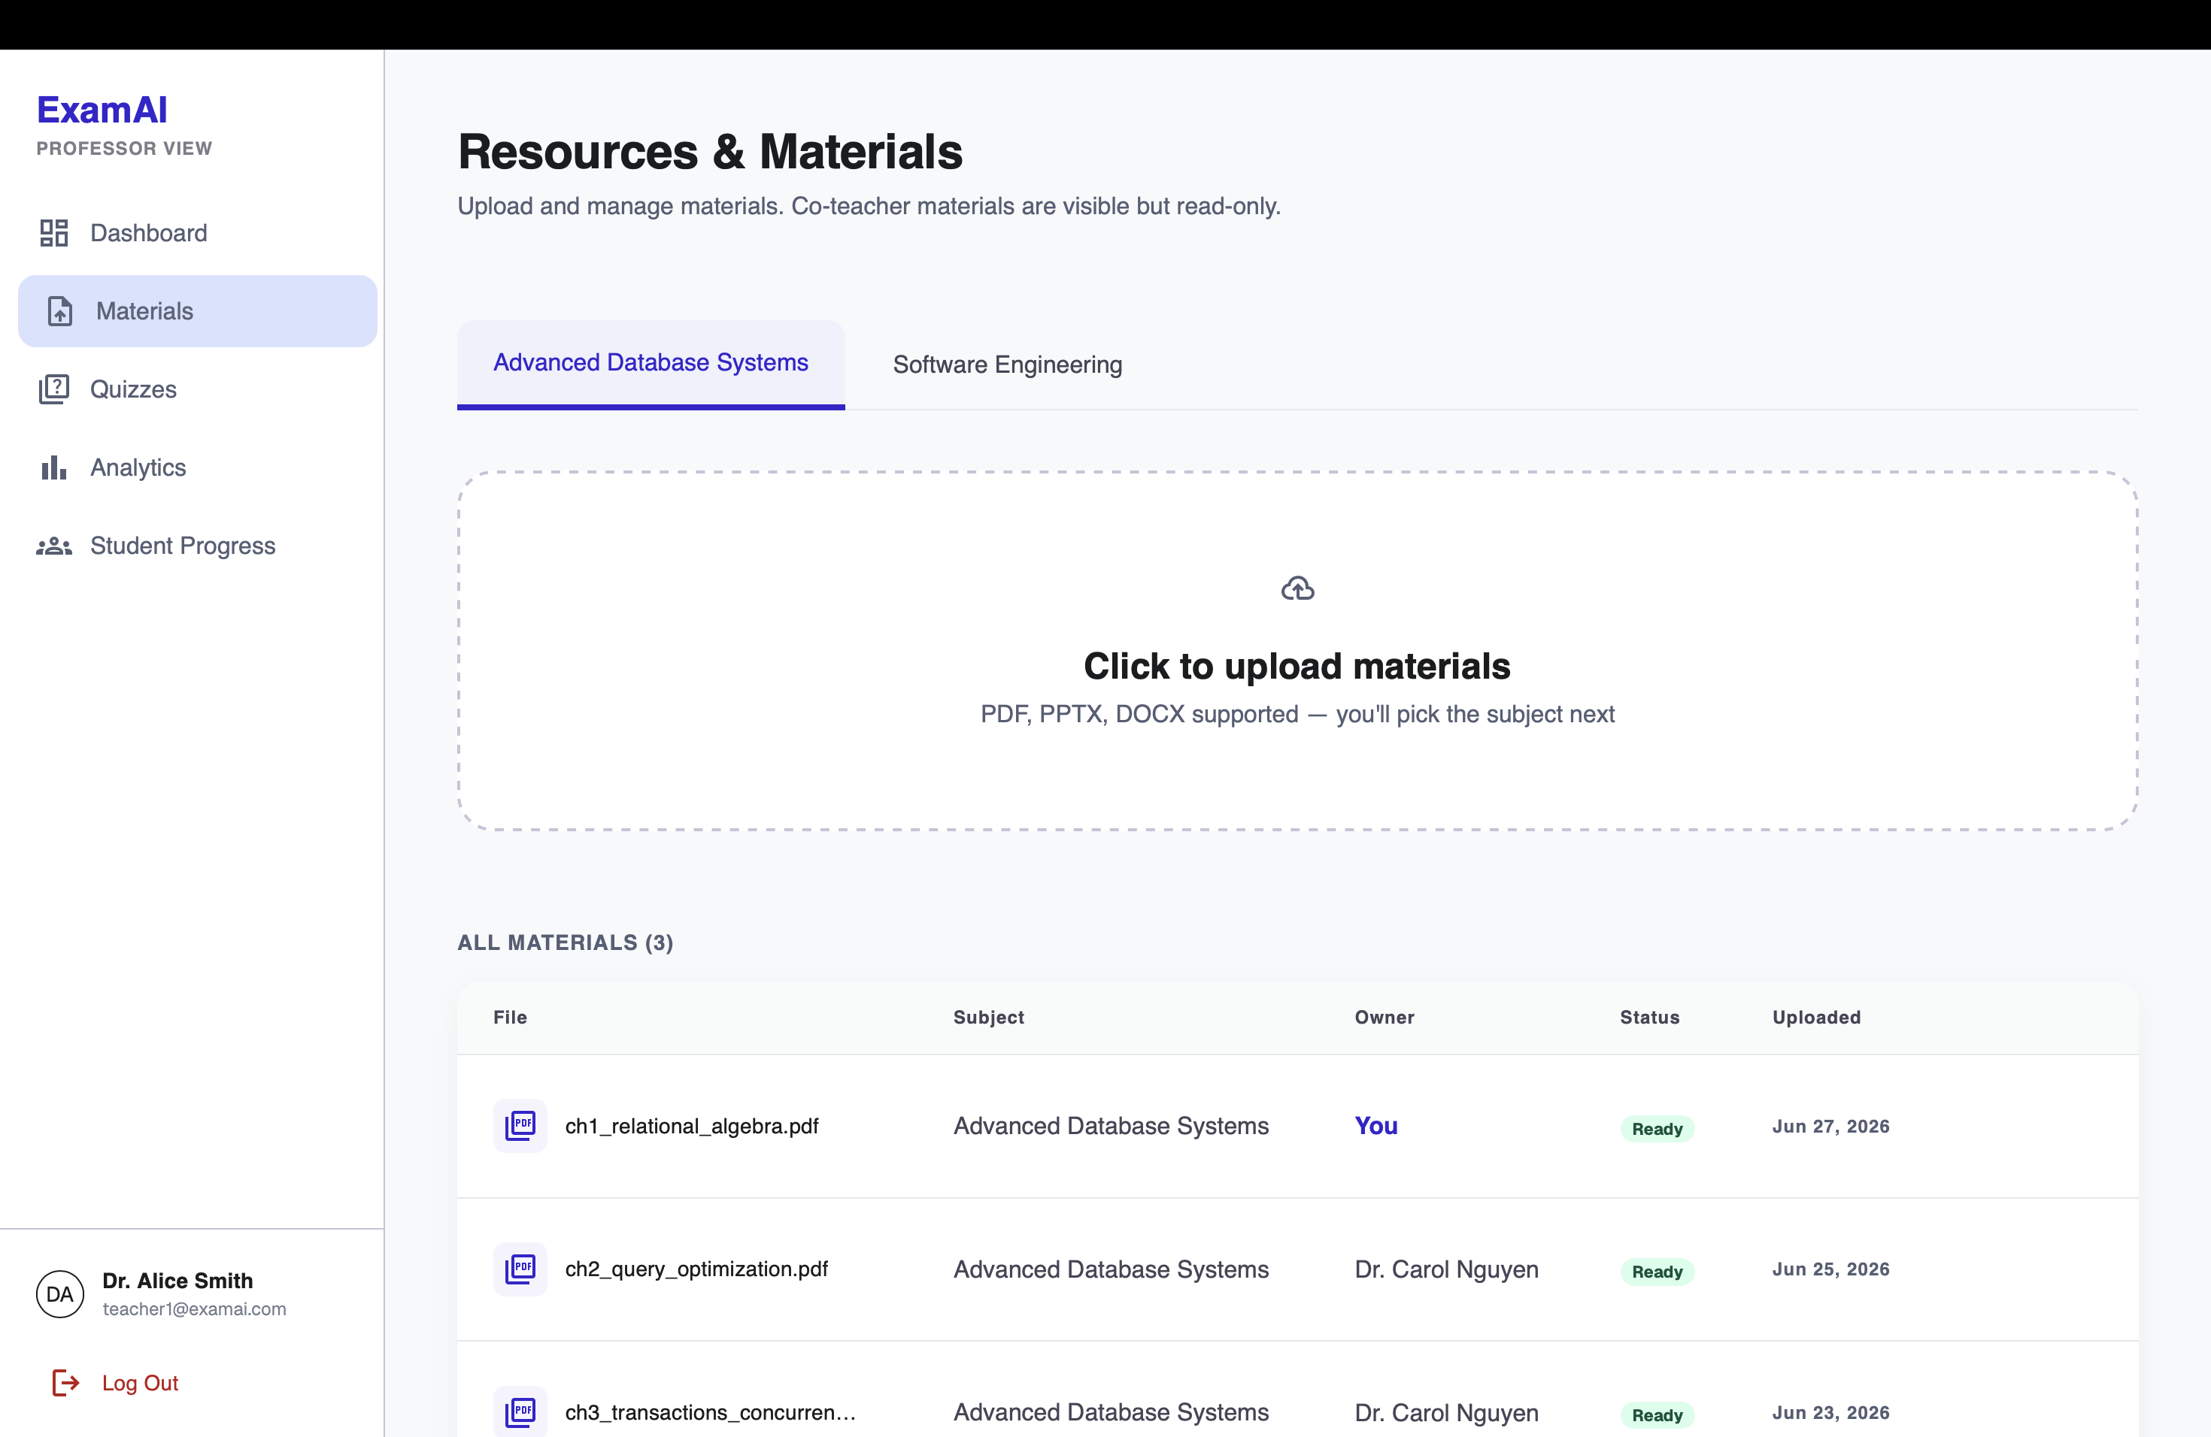
Figure 9.11: Teacher materials — upload dropzone, subject tabs, owner column separating own vs co-teacher files, Ready status badges.

9.7 Teacher Quiz Authoring and Publishing
The quiz list states the fairness rule directly: "All students in a subject take the same published quiz." Each card carries a Draft/Published badge and a Manual/AI source tag, with Edit, Publish, and delete actions — drafts expose a Publish button while published quizzes do not. Teachers author manually question by question, or request an AI-assisted draft generated from ready material; both paths produce the same question shape, and AI drafts remain drafts until reviewed and published.
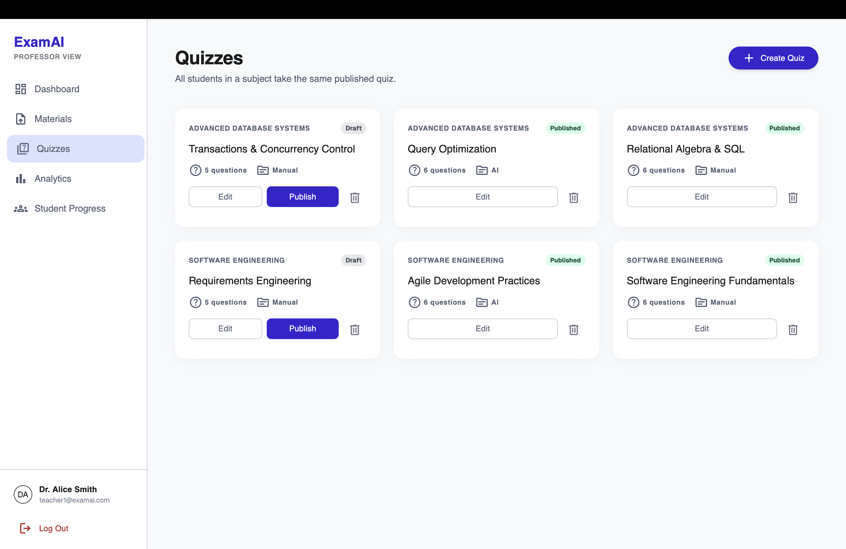
Figure 9.12: Teacher quiz list — draft/published badges, manual/AI source tags, publish flow.

9.8 Teacher Analytics and Student Progress
The analytics design deliberately separates per-quiz analysis from cross-quiz student progress. The per-quiz view (Figure 9.13, captured on a 17-student class with 16/17 completion and a 79% average) shows a question-accuracy heatmap with a Good/OK/Weak/Poor key, an A–F grade distribution, and the derived weak topic ("Indexing" at 69% class accuracy) — answering "how did this quiz go?". The student progress roster (Figure 9.14) lists every student with average score, completion bar, last-active date, and an At Risk / On Track badge, with a "7 at-risk" summary counter, name search, and subject filter on top and a drill-down chevron per row — answering "how is this student doing?". The teacher dashboard (Figure 9.15) adds an at-a-glance overview: active students, subject materials, quizzes created, and average section score (22 / 7 / 6 / 70% in the capture), with a recent-activity feed of who completed which quiz at what score, a grade-distribution summary, and an AI-insights card. Keeping these read models separate avoids forcing two different questions into one overloaded query.
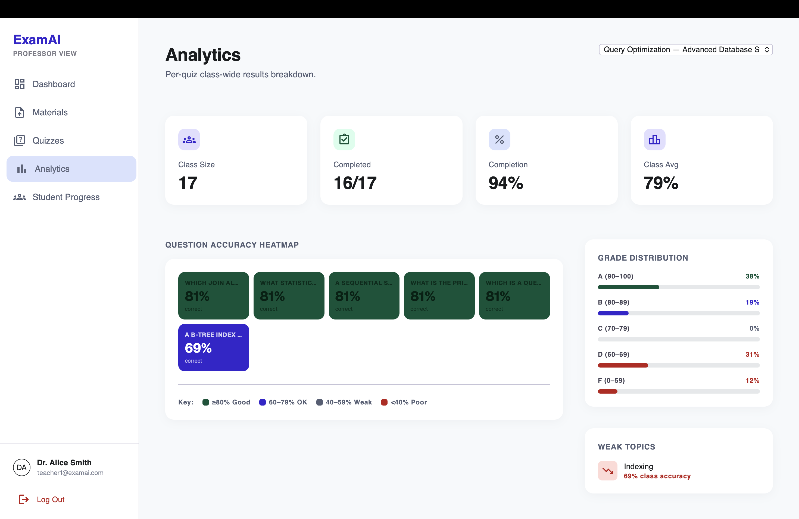
Figure 9.13: Per-quiz analytics — class stats, accuracy heatmap, grade distribution, weak topics.
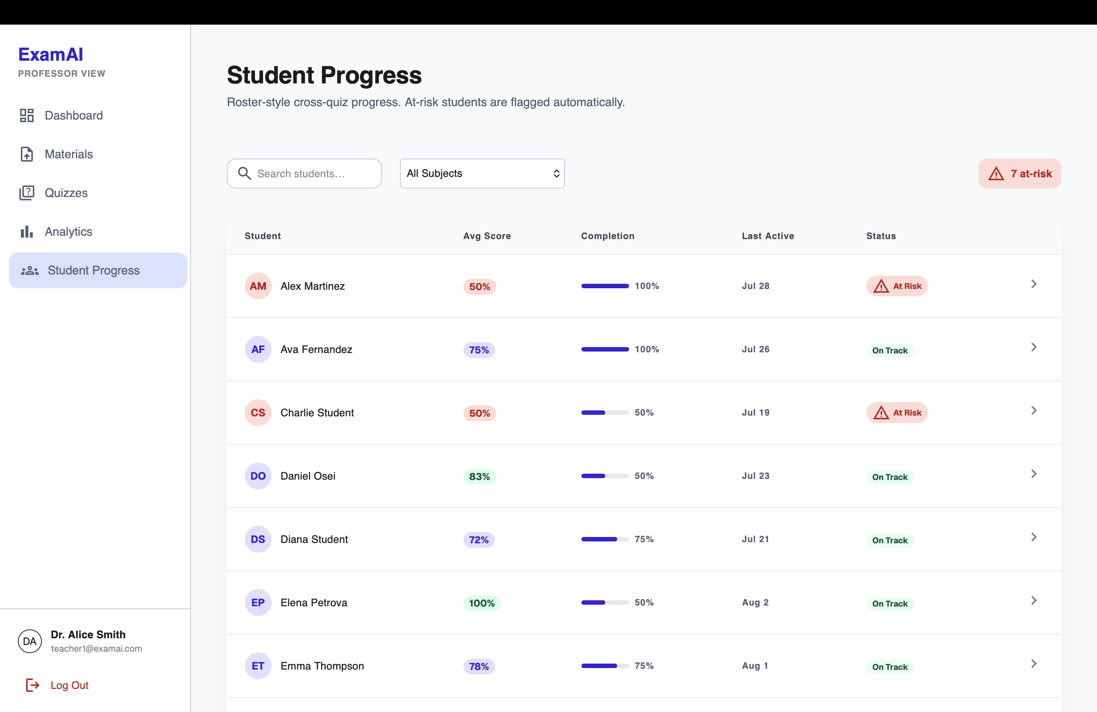
Figure 9.14: Student progress roster — averages, completion, at-risk flags with drill-down.
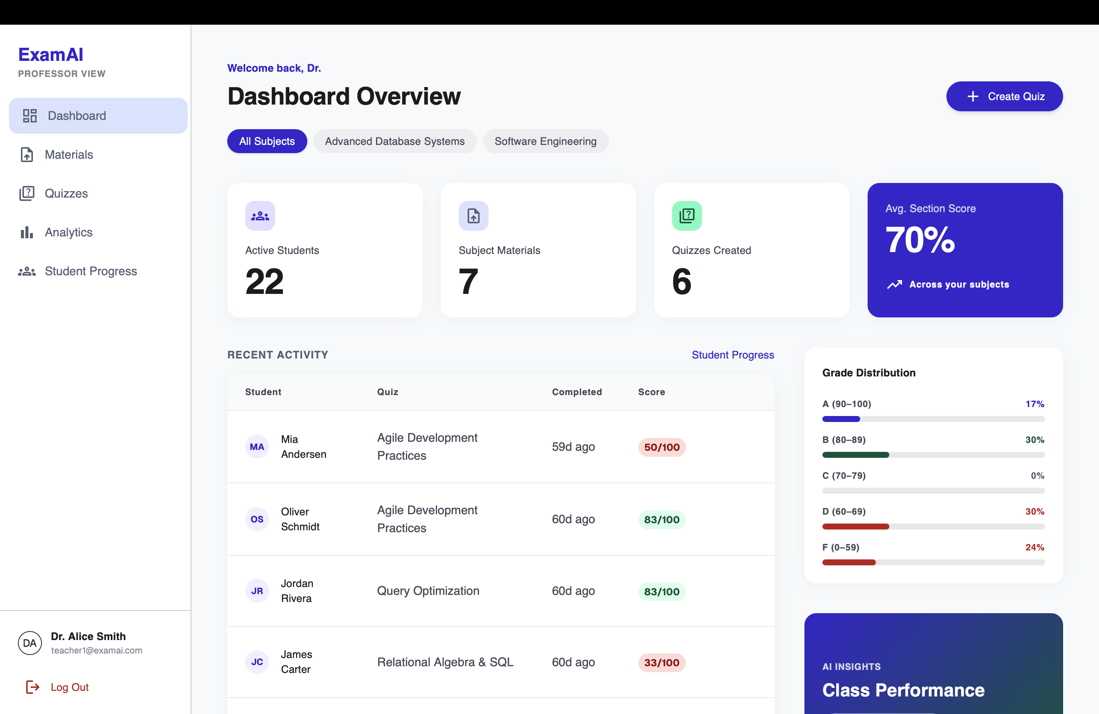
Figure 9.15: Teacher dashboard overview — activity stats, recent completions, grade distribution, AI insights.

9.9 Admin Console and Membership Management
An administrator (admin@examai.com, seeded) signs in through the same form and lands on the Admin View (/admin/users), which has no subject workspace — only Users, Subjects, and Membership pages behind require_admin. The Users list (Figure 9.16) shows all teacher/student accounts with search and All/Teachers/Students filters (31 shown in the capture), role badges, an Add user action, and a per-row drill-down into that user's subjects with edit and delete actions. Expanding a teacher row (Figure 9.17) reveals the assigned subjects with the same management actions. The Subjects list (Figure 9.18) shows every subject with an Add subject action, while expanding a subject (Figure 9.19) reveals its teacher and student rosters. The Membership page (Figure 9.20) assigns or removes a teacher/student for a chosen subject via subject, kind, and user selectors with Assign/Remove actions. Creation provisions the Supabase Auth account first and then the local profile with the same UUID (duplicate email returns 409); admins cannot create other admins and cannot delete themselves. Membership changes only manage the subject_teachers / student_subjects relations — they never bypass subject authorization for study or analytics data.
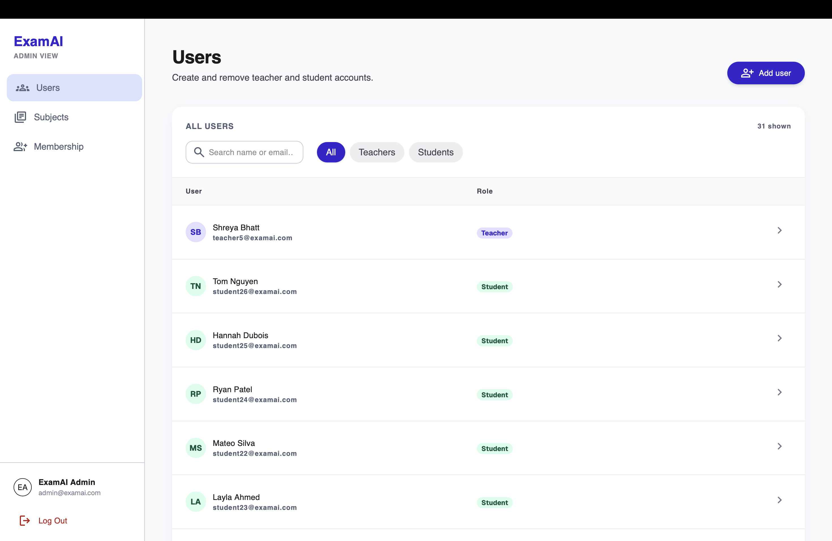
Figure 9.16: Admin users — full account list with search, role filter, role badges, and per-row subject drill-down.
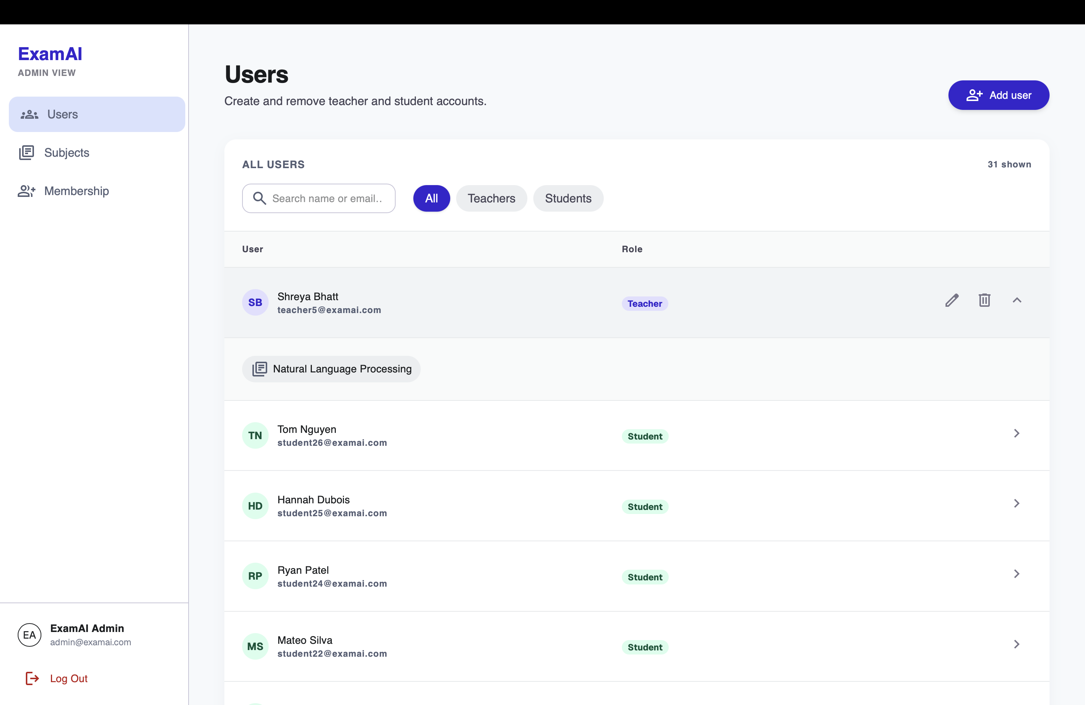
Figure 9.17: Admin user drill-down — expanded teacher row showing assigned subjects with edit and subject actions.
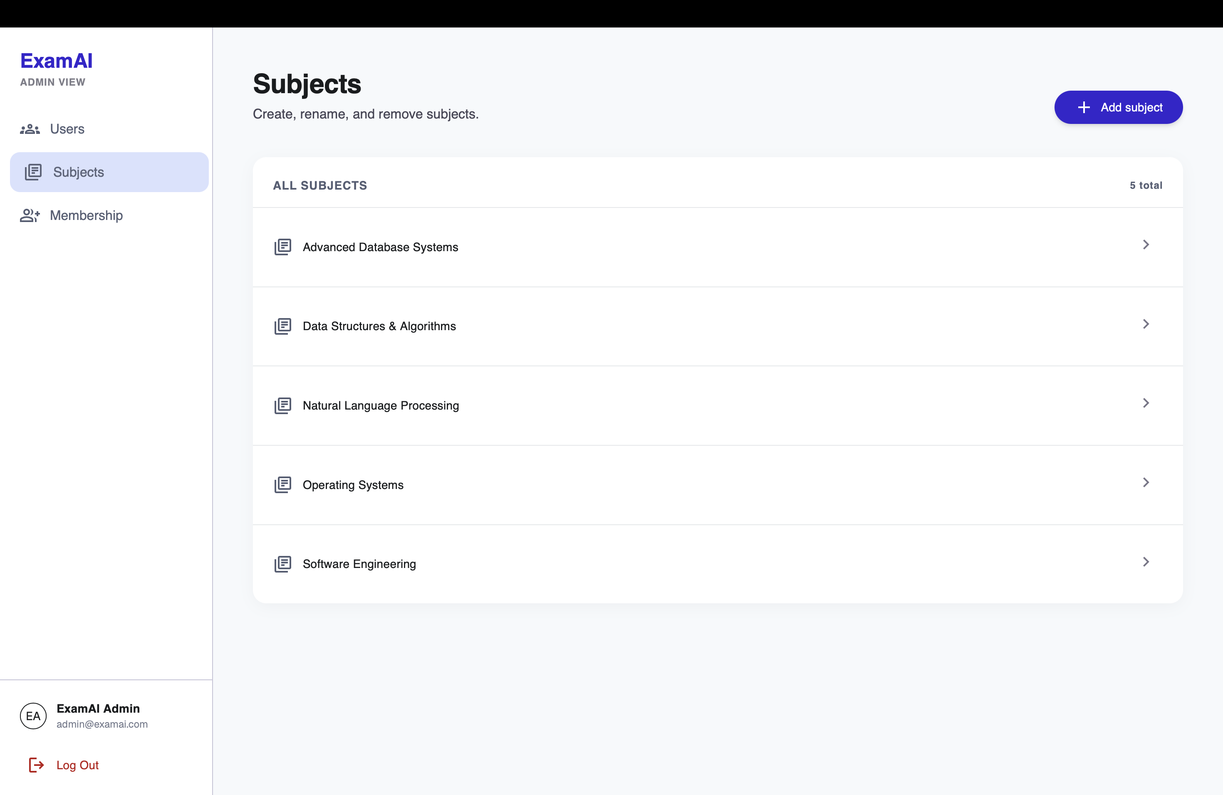
Figure 9.18: Admin subjects — full subject list with add action.
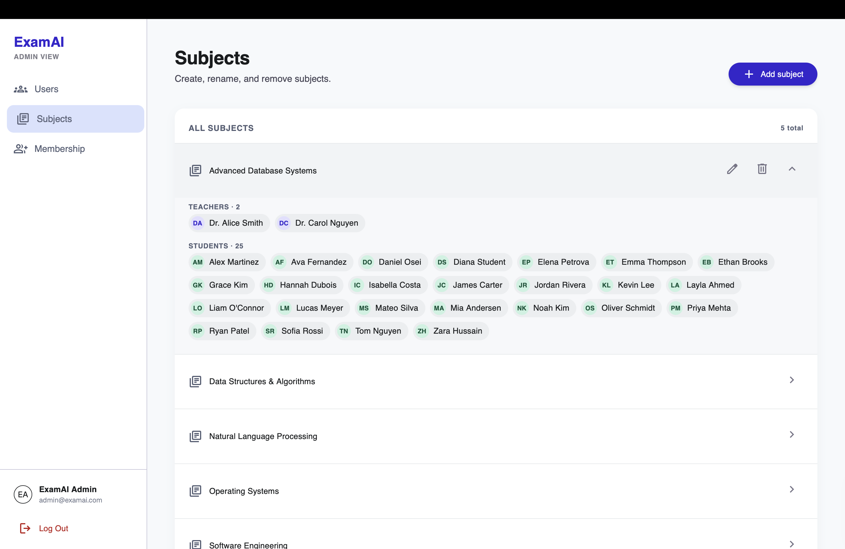
Figure 9.19: Admin subject drill-down — expanded subject showing teacher and student rosters.
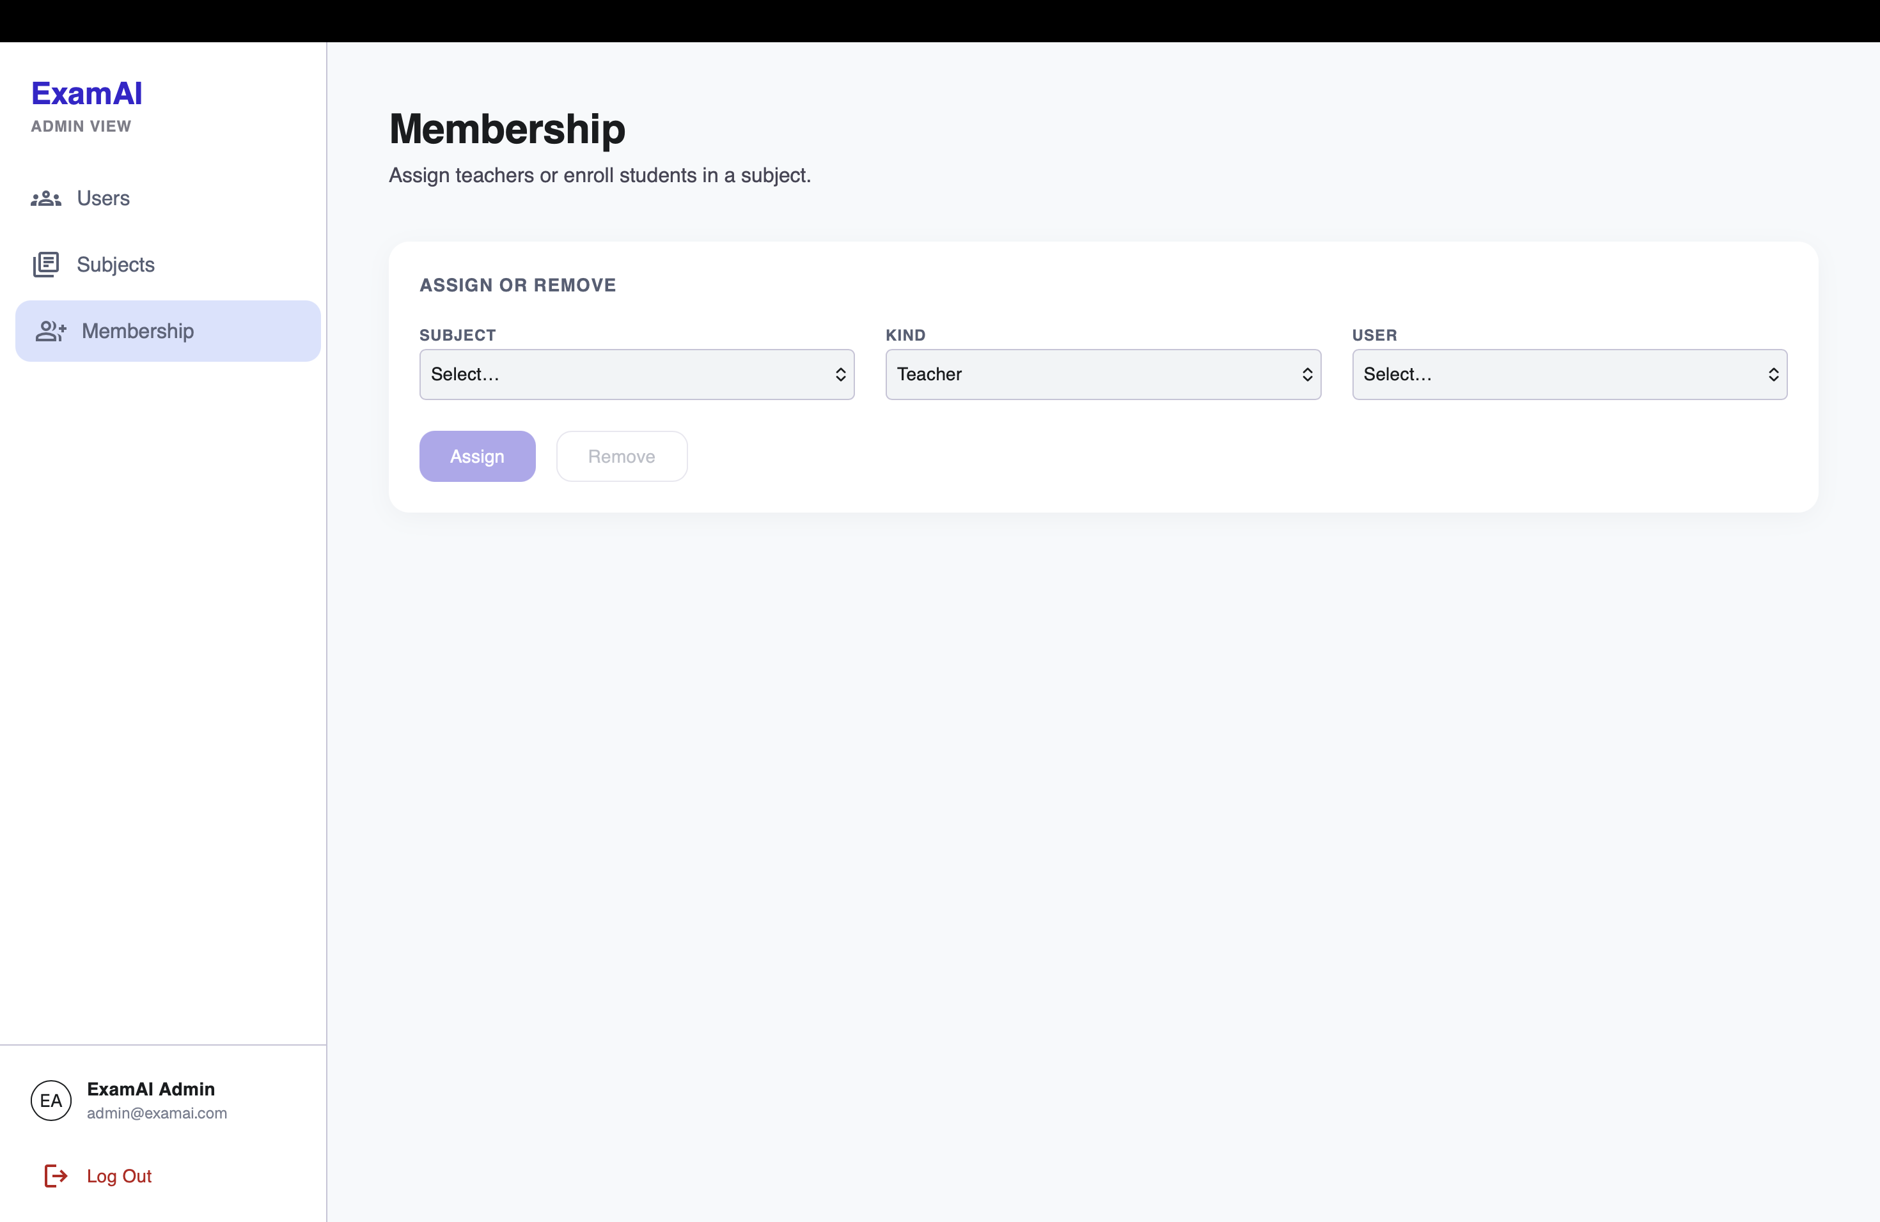
Figure 9.20: Admin membership — assign or remove a teacher/student for a subject by subject, kind, and user.

9.10 Security and Reliability Results
Access tokens are kept in memory with a HttpOnly refresh cookie; the API client performs one silent refresh-and-replay after a 401 before redirecting to login. CORS uses an allow-list and storage paths are never serialized to clients. Authorization checks are repeated in services rather than relying on route declarations alone. The ingestion pipeline uses per-material locks, row-level guards, and version-safe updates, with blocking parser and embedding calls moved off the event loop. Structured generation uses Pydantic schemas as the output contract, retrying with the error, the bad response, and the schema on failure. These patterns improve reliability without pretending external AI services are deterministic.

9.11 Overall System Performance
The backend suite (103 tests) runs fully offline in under a second; the frontend suite (84 tests) runs under Vitest with route, store, and component coverage. Frontend performance work includes route-level code splitting, navigation prefetching, bounded safe-GET caching, concurrent request deduplication, debounced search, loading skeletons, and stale-response handling — targeting measured responsiveness while preserving correctness. The known performance caveat is dependence on hosted services (database, vector store, model API) at deployment time: latency and quota there are deployment properties, and online hosting remains planned future work (Chapter 10).

CHAPTER 10
LIMITATION AND FUTURE ENHANCEMENT

▪ LIMITATION
▪ FUTURE ENHANCEMENT

CHAPTER 10 LIMITATION AND FUTURE ENHANCEMENT

10.1 Limitation
- ExamAI is a web application only — there is no mobile app yet.
- Users are provisioned by the seed operation plus runtime admin user management (admin@examai.com); there is no public signup, password reset, or OAuth.
- The generated answer is limited by the quality and coverage of uploaded material. Source attribution identifies the retrieved passage but does not guarantee the model's interpretation is correct; teachers must review AI-assisted quizzes before publication.
- Retrieval is dense-vector only; sparse/keyword signals (exact terms, codes, formulae) are not separately indexed.
- Generation features depend on the configured Gemini model, quota, and billing, which must be verified per deployment.
- There is no in-app teacher–student messaging or broadcast, and no payment or purchase flow.
- Analytics describe quiz attempts within the application; they do not claim to measure long-term learning outcomes.

10.2 Future Enhancement
- Add hybrid dense-plus-sparse retrieval and compare retrieval quality on a controlled dataset.
- Add richer source previews (page/slide thumbnails) and material version history.
- Introduce student-generated personal practice quizzes as explicit v2 scope, kept separate from shared graded assessment.
- Add institutional identity integration and deployment observability (logging, metrics, backups); extend the delivered administrator console (bulk import, audit log) as needed.
- Build mobile clients against the existing REST API without backend changes.
- Run accessibility audits and extend evaluation to citation correctness, quiz quality, and study outcomes.

CHAPTER 11
CONCLUSION

▪ CONCLUSION

CHAPTER 11 CONCLUSION

11.1 Conclusion
ExamAI brings teacher-controlled study help, shared assessment, personal revision, class-wide analytics, and centralized administration together into a single role-aware platform (student, teacher, admin) — closing the three gaps found in existing learning platforms during the literature survey: unattributed answers, incomparable assessments, and scattered teacher oversight.
The project was built end to end — from a versioned relational data model and a metadata-preserving ingestion pipeline, through filtered retrieval and schema-guarded generation, to a responsive React interface with teacher dashboards and an admin console — and is verified by 103 offline backend tests and 84 frontend tests plus manual end-to-end passes. Building it strengthened practical skills in full-stack architecture, authorization design, retrieval systems, working with non-deterministic AI components, and keeping academic comparability intact while adding AI assistance.
While the current version has known limitations, documented openly as limitations rather than left to be discovered later, the platform already delivers on its core goal: a student always knows which teacher's material — and which page — an answer came from, a teacher always sees how the whole class performed on the same questions, and an administrator can provision every account, subject, and membership from one console.

CHAPTER 12
APPENDICES

▪ BUSINESS MODEL
▪ PRODUCT DEPLOYMENT DETAIL
▪ API AND WEB SERVICE DETAILS

CHAPTER 12 APPENDICES

12.1 Business Model
ExamAI is currently built and presented as an academic project rather than a commercial product. If extended toward institutional use, it would naturally fit a department-level service model — the platform hosted for a department or coaching organization with teacher-managed subjects, private file storage, and usage-based AI limits. Any such model would require clear privacy, data-retention, accessibility, and service-cost policies. The current report makes no commercial deployment claim.

12.2 Product Deployment Detail
For local development, the backend runs from the backend/ directory with Python 3.14 and its canonical virtual environment; migrations apply via Alembic, demo data seeds through the project seed command, and the FastAPI service exposes its API and documentation. The frontend starts with Vite and targets the configured API base URL.
Component | Hosting | Role
Frontend | Static build (Vite output) | Serves the React application to users
Backend | Render.com (FastAPI via Uvicorn) | Serves the REST API
Database/Auth/Storage | Supabase (managed Postgres) | Users, subjects, materials, quizzes, attempts, decks; private files
Vector search | Qdrant Cloud (single collection) | Embedded material chunks with filterable payloads
Generation | Gemini API | Structured chat, quiz, and flashcard generation

Table 12.1: Product deployment layout.
Online deployment is planned but not yet carried out; the current delivery is a verified local prototype with a defined production layout as tabulated above.

12.3 API and Web Service Details
ExamAI exposes its functionality through a RESTful API built with FastAPI. Every endpoint is documented automatically and can be explored interactively at /docs on the backend. Responses use a standardized envelope with request identification.
Method | Endpoint | Description
POST | /api/auth/login | Log in a provisioned user; role (student, teacher, admin) derived from profile
GET | /api/subjects | List accessible subjects for the current role
POST | /api/materials | Teacher upload of PDF/PPTX/DOCX with status tracking
POST | /api/chat | Ask a question over subject + selected material IDs
GET/POST | /api/quizzes | List / create (manual or AI-assisted) quizzes; publish flow
POST | /api/quizzes/{id}/attempts | Submit an attempt; server-side grading with weak topics
GET/POST | /api/flashcards/decks | List / generate personal decks; mastery updates
GET | /api/analytics/quiz/{id} | Per-quiz heatmap, distribution, weak topics
GET | /api/analytics/progress | Cross-quiz roster with at-risk flags
GET/POST/PATCH/DELETE | /api/admin/users | Manage teacher/student accounts (paginated list, search, drill-down subjects); admins cannot create other admins
GET/POST/PATCH/DELETE | /api/admin/subjects | Manage subjects with member drill-downs
POST/DELETE | /api/admin/subjects/{id}/teachers, /students | Assign/remove teachers, enroll/remove students

Table 12.2: API and web service summary.
Authentication is session/token based: the access token is kept in memory on the client with a HttpOnly refresh cookie, and every subject-scoped call re-checks enrollment or membership in the service layer. Administration is gated separately by require_admin and only manages those relations — it never bypasses them. The seed provisions the admin@examai.com administrator; admins use the /admin/* console (Users, Subjects, Membership), not a subject workspace.

BIBLIOGRAPHY
1. Moodle Project. Moodle LMS documentation. https://docs.moodle.org/
2. Google. Google Classroom Help. https://support.google.com/edu/classroom/
3. Quizlet. Flashcards and study tools. https://quizlet.com/
4. OpenAI. ChatGPT. General-purpose large language model chatbot. https://openai.com/chatgpt/overview/
5. Google. NotebookLM. Retrieval-grounded study assistant over user-supplied sources. https://notebooklm.google.com/
6. Lewis, P., Perez, E., Piktus, A., Petroni, F., Karpukhin, V., Goyal, N., Küttler, H., Lewis, M., Yih, W., Rocktäschel, T., Riedel, S., & Kiela, D. (2020). Retrieval-augmented generation for knowledge-intensive NLP tasks. In Advances in Neural Information Processing Systems (Vol. 33, pp. 9459–9474). https://proceedings.neurips.cc/paper/2020/hash/6b493230205f780e1bc26945df7481e5-Abstract.html
7. Karpukhin, V., Oğuz, B., Min, S., Lewis, P., Wu, L., Edunov, S., Chen, D., & Yih, W. (2020). Dense passage retrieval for open-domain question answering. In Proceedings of the 2020 Conference on Empirical Methods in Natural Language Processing (EMNLP) (pp. 6769–6781). Association for Computational Linguistics. https://doi.org/10.18653/v1/2020.emnlp-main.550
8. Reimers, N., & Gurevych, I. (2019). Sentence-BERT: Sentence embeddings using Siamese BERT-networks. In Proceedings of the 2019 Conference on Empirical Methods in Natural Language Processing and the 9th International Joint Conference on Natural Language Processing (EMNLP-IJCNLP) (pp. 3982–3992). Association for Computational Linguistics. https://doi.org/10.18653/v1/D19-1410
9. Ji, Z., Lee, N., Frieske, R., Yu, T., Su, D., Xu, Y., Ishii, E., Bang, Y. J., Madotto, A., & Fung, P. (2023). Survey of hallucination in natural language generation. ACM Computing Surveys, 55(12), Article 248, 1–38. https://doi.org/10.1145/3571730
10. Huang, L., Yu, W., Ma, W., Zhong, W., Feng, Z., Wang, H., Chen, Q., Peng, W., Feng, X., Qin, B., & Liu, T. (2025). A survey on hallucination in large language models: Principles, taxonomy, challenges, and open questions. ACM Transactions on Information Systems, 43(2), Article 42, 1–55. https://doi.org/10.1145/3703155
11. Es, S., James, J., Espinosa-Anke, L., & Schockaert, S. (2023). RAGAS: Automated evaluation of retrieval augmented generation. arXiv preprint arXiv:2309.15217. https://arxiv.org/abs/2309.15217
12. Roediger, H. L., III, & Karpicke, J. D. (2006). Test-enhanced learning: Taking memory tests improves long-term retention. Psychological Science, 17(3), 249–255. https://doi.org/10.1111/j.1467-9280.2006.01693.x
13. Cepeda, N. J., Pashler, H., Vul, E., Wixted, J. T., & Rohrer, D. (2006). Distributed practice in verbal recall tasks: A review and quantitative synthesis. Psychological Bulletin, 132(3), 354–380. https://doi.org/10.1037/0033-2909.132.3.354
14. Kasneci, E., Seßler, K., Küchemann, S., Bannert, M., Dementieva, D., Fischer, F., Gasser, U., Groh, G., Günnemann, S., Hüllermeier, E., Krusche, S., Kutyniok, G., Michaeli, T., Nerdel, C., Pfeffer, J., Poquet, O., Sailer, M., Schmidt, A., Seidel, T., Stadler, M., Weller, J., Kuhn, J., & Kasneci, G. (2023). ChatGPT for good? On opportunities and challenges of large language models for education. Learning and Individual Differences, 103, Article 102274. https://doi.org/10.1016/j.lindif.2023.102274
15. Siemens, G., & Long, P. (2011). Penetrating the fog: Analytics in learning and education. EDUCAUSE Review, 46(5), 30–32. https://er.educause.edu/articles/2011/9/penetrating-the-fog-analytics-in-learning-and-education

